Template Version 1.0
May 2018

Letter of Request for
{Project Name}

{County, Iowa}

Project Number {IMN-XXX-X(XXX)XX—XX-XX}

Prepared for:

{Month Day, Year}

Instructions for Using Template
Use this template as a starting point for writing a Letter of Request related to an access change request. This template provides materials to be supplied in all Letters of Request and in the order in which the materials are to be presented. The user is encouraged to follow this template as strictly as possible to provide consistency for documentation. The Iowa Department of Transportation recognizes that every project is unique, and modifications to template materials and organization of materials may be necessary to meet the unique characteristics of a project. This template should be used in conjunction with the Iowa DOT User Guide for New or Revised Interchange Access. Section 4.2 of the Iowa DOT User Guide for New or Revised Interchange Access provides guidance pertaining to the Letter of Request.
The page layout for this template is generally 8 ½” x 11” portrait, and this should be maintained by the user. It may be appropriate to provide figures or tables on pages that are 11” x 17” landscape.
Text in this template is color-coded to identify user inputs, instructions and standard text, as follows:
- Text highlighted yellow is a user input. This text should be replaced with the appropriate text or value, and the highlight should be removed.
- Text in {brackets} is also a user input. This text is part of a heading or title, and the formatting of this text should not be altered. The {brackets} surrounding the text should be deleted when inputting/updating this text.
- Text in bold/orange is instructional to help the user complete the document. This text should be deleted from the document once the user has followed the instructions provided by this text.
- Text that is bold/red is a reference to a table or figure. This format should be used for all references to tables and figures.
- Text that is black or a hyperlink is standard text that should generally not be edited.
Example tables and figures are provided in this template. These tables and figures should be populated, replaced or deleted as appropriate. Table and figure title numbers are set up to reference the appropriate section of the document and the appropriate table or figure number within each section. The reference to tables and figures within the body of the document is cross-referenced to the table or figure title. When adding tables or figures, the user should match the formatting of provided tables and figures (including table/figure titles and references within the body). When adding or removing tables or figures, the provided table and figure title numbers and references within the body should be updated.
Page breaks are inserted at locations throughout the template for readability of the template. The user should remove page breaks where appropriate.
Double-click in the header and Word will automatically update the project name and date after filling out the cover page.
The lists for Contents, Tables and Figures on the following page(s) should be updated after completing the document.
This page is to be deleted prior to submittal.
District X Office/Highway Division
Address l City, State Zip
Phone: XXX-XXX-XXXX l Email: Email@iowadot.us

For projects where the Letter of Request is used to complete the approval of the access change, and following review and approval by the Iowa DOT District Engineer, a letter of approval by the District Engineer for the Letter of Request is sent via email to the FHWA, Iowa Division for approval (a letter of approval is not issued for the Letter of Request on projects that include an IOR or IJR). This email is sent to Iowa.FHWA@DOT.gov. Typically for this action, a ProjectWise link to the Letter of Request is sent to FHWA with this letter of approval attached to the email. Once the FHWA has approved the Letter of Request, the FHWA will submit a letter of approval. The letters of approval by the Iowa DOT and FHWA should be filed with the final Letter of Request that is approved.
This page should be used as a guide when preparing the Iowa DOT letter of approval. Remove this page from the Letter of Request document that is submitted for reviews.
Month Day, Year

Program Delivery Team Leader
FHWA, Iowa Division
105 6th Street
Ames, Iowa 50010

Subject: Project Name Letter of Request
Project Number IMN-XXX-X(XXX)XX—XX-XX

Dear Program Delivery Team Leader,

I have approved this Letter of Request, dated Month Day, Year, for the proposed access revisions and I am submitting it to FHWA for approval.

Sincerely,

Add Signature

Name
District X Engineer

Contents
1 Introduction 1
2 Location 1
3 Problem Definition 3
4 Project Limits 3
5 Build Alternatives 6
6 Project Development Schedule 8
7 Funding Strategy 8
8 Compatibility with Roadway Network 9
9 Local Agency Support 9

Tables
Table 6-1. Anticipated Project Development and Construction Schedule 8
Table 7-1. Anticipated Project Funding Sources 9

Figures
Figure 2-1. Project Location Map 2
Figure 2-2. Land Use Map 3
Figure 4-1. Approximate Limits of Physical Improvements 4
Figure 4-2. Area of Influence 5
Figure 5-1. Build Alternative Conceptual Layout 7

This page is intentionally left blank.

Introduction
This Letter of Request is being submitted by/on behalf of agency name to notify the Iowa DOT and FHWA of proposed change in access to Interstate facility at crossroad (mile marker) in County, Iowa. The proposed access change would describe the changes that would be made by the proposed access change. The access change request is being made to state the goals and objectives of the proposed access change. This Letter of request provides the background for and proposal of the aforementioned access change improvements.
The requesting agency name is seeking guidance from the project Advisory Group, made up of Iowa DOT and FHWA staff, on the feasibility of proposed improvements, and level of analysis and documentation that will be required to complete the access change request. The Advisory Group will be asked to participate in the project through coordination meetings and review/comment of access change request documents.
For projects where the Letter of Request is intended to complete the approval for the access change request, as may be the case for minor projects, the above paragraph should be modified to state, “The requesting agency name is seeking approval from the Iowa DOT and FHWA of the proposed access change documented in this Letter of Request.”

Location
The project is located describe the location in relation to surrounding communities and the project facilities. Example of project location description for example graphic provided in Figure 2.1 below: The project is located at the I-80 / 1st Avenue interchange in eastern Coralville, Iowa, immediately west of the Iowa River. The location of the project is shown in Figure 2-1 in relation to surrounding communities and facilities.
For projects where a new interchange or major modifications to an existing interchange are proposed, provide additional description of the project and surrounding features that have influence on one another. This may include a list of the intersections or interchanges immediately adjacent to the project. This should also include description of predominant land use types surrounding the project, and may also include a figure showing land uses. An example outline of adjacent intersections or interchanges and land use description is provided below. For projects with minor improvements to an existing interchange, delete the example text below.
Intersections or interchanges immediately adjacent to the project include:
- I-80 / Coral Ridge Avenue interchange west of the project.
- I-80 / Dubuque Street interchange east of the project.
- 1st Avenue / E 9th Street intersection south of the project.
- 1st Avenue / Russell Slade Boulevard intersection north of the project.
The land uses surrounding I-80 at 1st Avenue (mile marker 242) are a mix of commercial, industrial and residential uses. A map showing the land uses in the area is provided in Figure 2-2.
Figure 2-1. Project Location Map
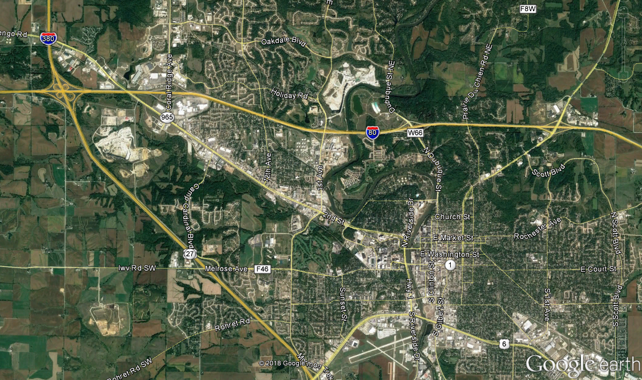
Iowa City
Coralville
Oakdale
Project Location
N
(Replace this example graphic with project location graphic)
The figure used to show the project location should include an area of sufficient size to identify the project area in relation to surrounding communities and nearby features or facilities.

Figure 2-2. Land Use Map
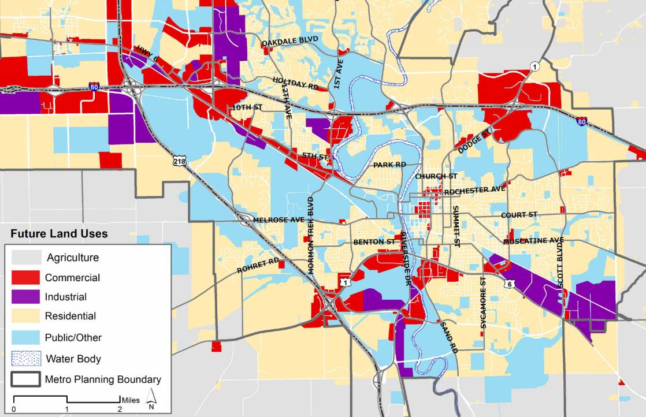
Source: MPO of Johnson County – 2045 Long Range Transportation Plan
(Remove this example graphic if it is determined not necessary, or replace this example graphic with project area land use map if one is available)

Problem Definition
Problem definition.
Describe the problem that is being addressed with the proposed access change, including the goals and objectives to be achieved.

Project Limits
For projects with minor improvements to an existing interchange, such as improvements isolated to ramp terminal intersections, this section should be simplified from the provided template materials. For these projects, provide a simple statement that mentions the limits of the project, such as: “Proposed improvements are limited to the I-80 / 1st Avenue ramp terminal intersections.” Also provide a simple statement that identifies the area of influence, which may include closely spaced intersections adjacent to the interchange, such as: “The area of influence for operational and safety analyses includes the ramp terminal intersections and adjacent signalized intersection to the south at E 9th Street.” Figures that show limits of physical improvements and area of influence are typically not necessary for projects with minor improvements to an existing interchange. For projects where a new interchange or major modifications to an existing interchange are proposed, follow the template materials in this section.
The project is located on Interstate facility at crossroad (mile marker). As shown in Figure 4-1, the proposed access change has the following approximate limits of physical improvements:
- West Limits: XXXXX.
- East Limits: XXXXX.
- South Limits: XXXXX.
- North Limits: XXXXX.
Example of approximate limits of physical improvements for example graphic in Figure 4-1:
- West limits: Approximately 2,000 feet west of 1st Avenue bridge over I-80.
- East limits: Approximately 2,000 feet east of 1st Avenue bridge over I-80.
- South limits: Approximately 400 feet north of the existing I-80 westbound ramp terminal intersection with 1st Avenue.
- North limits: Immediately north of the 1st Avenue / 9th Street intersection.
Provide additional details to clearly define the approximate limits of physical improvement as appropriate.
Figure 4-1. Approximate Limits of Physical Improvements
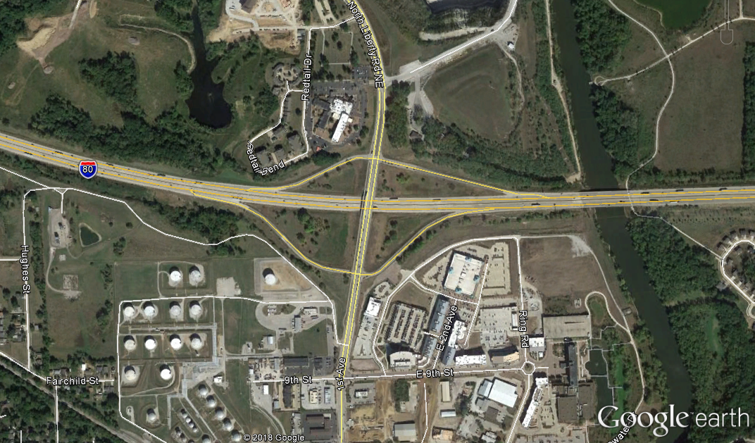
N
Approximate Limits of Physical Improvements
The area of influence for operational and safety analyses is shown in Figure 4-2. The area of influence includes freeway mainline, ramps, ramp terminal intersections and crossroad intersections within the boundaries:
- West Limits: XXXXX.
- East Limits: XXXXX.
- South Limits: XXXXX.
- North Limits: XXXXX.
Example of boundary summary for example graphic in Figure 4-2:
- West limits: West ramp junctions of the I-80 / Coral Ridge Avenue interchange (Exit 240).
- East limits: East ramp junctions of the I-80 / Dubuque Street interchange (Exit 244).
- South limits: 1st Avenue / E 7th Street intersection.
- North limits: 1st Avenue / Holiday Road intersection.
Provide additional details to clearly define the area of influence as appropriate.
Figure 4-2. Area of Influence
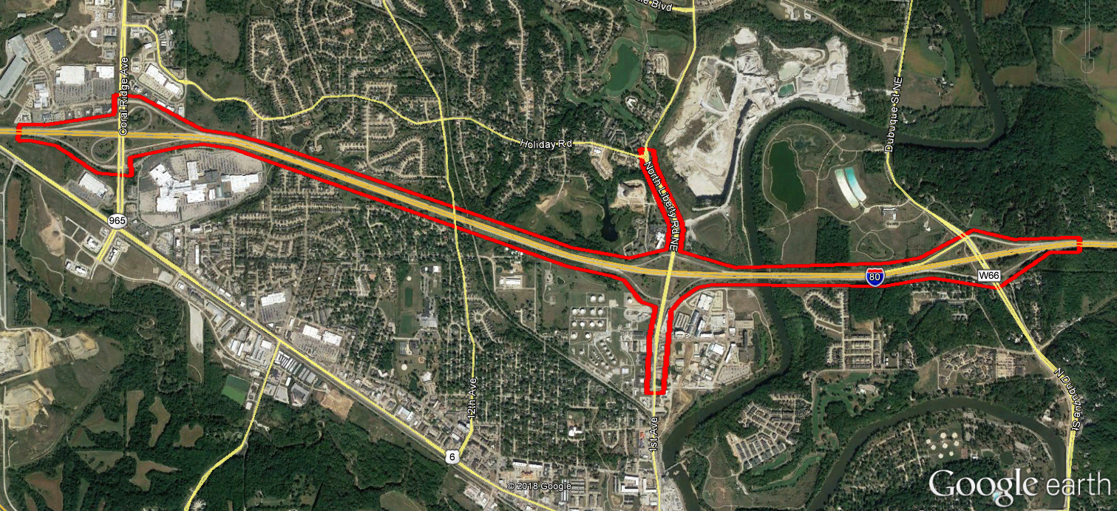
N
Area of Influence
(Replace this example graphic with project area of influence graphic)

Build Alternatives
Description of Build alternative(s).
Describe any concepts that are being considered for Build alternatives. These narratives should include a description of the improvements and how they meet the project goals and objectives. Include a figure for each concept if available. For projects with minor improvements to an existing interchange, a figure may not be necessary.

Figure 5-1. Build Alternative Conceptual Layout
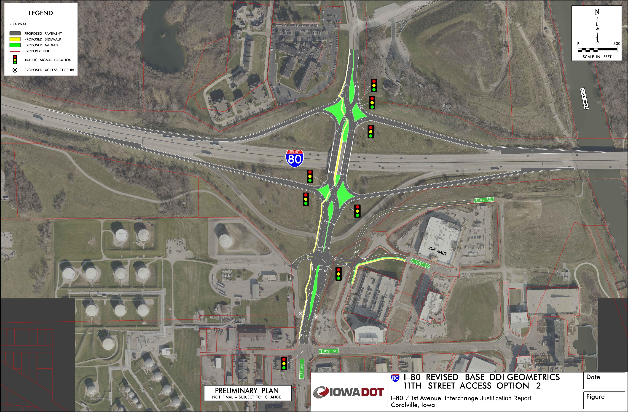
(Replace this example graphic with project conceptual layout graphic)

Project Development Schedule
For projects with minor improvements to an existing interchange, such as improvements isolated to ramp terminal intersections, a detailed project development schedule, as outlined in this section, may not be necessary. For these types of projects, it may be appropriate to delete this section or provide a simple statement similar to, “The proposed improvements are anticipated to be constructed in year 20XX.”
The anticipated schedule for the proposed project is shown in Table 6-1. The project is scheduled to be completed in Month of year.
Complete Table 6-1 below to reflect the scope and desired schedule of the proposed project. Add or remove rows and columns to this table as necessary. Denote any dates that have not been identified with “N/A”.
Table 6-1. Anticipated Project Development and Construction Schedule
Section | Start | Finish | 2018 | 2019 | 2020 | 2021 | 2022
IJR
NEPA Document
Preliminary Design
Final Design
Right-of-Way Acquisition
Construction

Funding Strategy
For projects with minor improvements to an existing interchange, such as improvements isolated to ramp terminal intersections, a detailed outline of funding sources, as outlined in this section, may not be necessary. For these types of projects, it may be appropriate to delete this section or provide a simple statement similar to, “The anticipated cost for the project is $XXX,XXX with Iowa DOT identified as the primary source for funding, as outlined in the XXXXX planning document.”
The project is currently listed in list local, regional and statewide planning documents. Table 7-1 provides the anticipated funding sources for the proposed project. The total estimated cost of the project is $XXX,XXX,XXX.
Describe the anticipated source(s) of funding for the proposed project, the years for which funding has been allocated and which planning documents include project funding. Identify grants or federal funding sources that have been obtained. Complete Table 7-1 below to reflect anticipated funding source(s) for the proposed project. Add or remove rows and columns to this table as necessary.
Note if potential funding sources have not been identified. For projects on the Interstate System that are not in a planning document, describe the steps being taken to have the project added in local/regional/state planning documents.
Table 7-1. Anticipated Project Funding Sources
Source | Amount
U.S. DOT | $XXX,XXX,XXX
Iowa DOT | $XXX,XXX,XXX
City | $XXX,XXX,XXX
Grant | $XXX,XXX,XXX
Total | $XXX,XXX,XXX

Compatibility with Roadway Network
For projects with minor improvements to an existing interchange, such as improvements isolated to ramp terminal intersections, a discussion on compatibility of the project with the adjacent roadway network may not be necessary. For these types of projects, it may be appropriate to delete this section or provide a simple statement similar to, “The proposed improvements will provide isolated improvement and are compatible with the roadway network.”
Compatibility with roadway network.
Describe the compatibility of the proposed access change with the adjacent roadway network. This should include details on the spacing of existing and proposed intersections and interchange ramps, connectivity with local roadways including their Federal Functional Classification, and any programmed or planned improvements within the area of influence.

Local Agency Support
For projects with minor improvements to an existing interchange, such as improvements isolated to ramp terminal intersections, a discussion on coordination with local agencies and their support may not be necessary. For these types of projects, it may be appropriate to delete this section or provide a simple statement similar to, “The proposed improvements will provide isolated improvement and are supported by local agencies.”
Local agency support.
Describe the coordination with local agencies and their level of support for the proposed project. Include any local, regional and statewide transportation plans that include the project.

