Pre-Installation Steps for Speed Feedback (SFB) sign
(Draft Dated 9/22/23 v9)
District (Traffic Tech): Receive an inquiry from a city. Confirm they are eligible:
______ Is the location(s) on a Primary Highway? (Excluding Interstates & Freeways)
______ Is the City’s population between 1,000+/- & 10,000+/-?
______ Are they willing to take ownership and maintain sign(s) after install?

District (Traffic Tech): If “Yes” to all 3 above, schedule a site visit with City Representative.
_____ e-mail them a blank TCD (SFB Specific) form with added language about ownership and maintenance responsibilities or send them to the website form here: https://iowadot.gov/traffic/Speed-Feedback-Signs
_____ Ask City where they would like them. If no preference, DOT recommends at 1st speed reduction.
_____ Complete the ‘Site visit / Installation details’ form for each location. https://iowadot.gov/traffic/Speed-Feedback-Signs
_____ Scan in the above mentioned form(s) and e-mail to ron.mcdaniel@iowadot.us in TAS along with a signed TCD permit application. Include a map showing all the proposed locations.
_____ Confirm with local garage that they will hang the SFB and Static Speed Limit sign on the pole.
_____ Order any Static Speed Limit Signs from Sign Shop (if necessary). Have delivery to local garage. Charge to NHSN-000-T(275)--2R-00).
TAS: Receive: 1) TCD permit, 2) Site visit / Installation details, and 3) Map attachments from District:
_______ (Ron & Willy) Confirm application meets the criteria and is signed by City (Electronic or signed/scanned).
_______ (Ron) Review the TCD Permit and forward to State Traffic Engineer for signature.
_______ (Chris) Return a signed copy to Ron, Brad & Traffic Tech.
_______ (Brad) Add location to TCD Database & Statewide SFB map (color code as “pending” or “installed”)
_______ (Ron/Willy) Add information to DOT excel spreadsheet in Sharepoint. (much of this info can be in the GIS layer, but keeping track of allocated inventory will be important. (Willy & Ron to work on details of this).
TAS: Once TCD has been approved, proceed to enter a work order into “Smart Sheets” to get Baker Electric to install the Footings/Base/Poles. (The contractor’s price to install assumes they can do 4 locations in one day-trip.)
- Description: Town, Route/Direction, Speed Limit, GSP Coordinates
- Sign Font Size: 12” or 18”
- Sign vendor: Traffic Logix (12”), Carmanah (18”) or Stalker (18”)
- Length of Pole: Copy from application (13’, 15’, 16’, or 18’)
- Install Pole only? Or do we need contractor to hang SFB sign also (usually, DOT Maintenance will hang SFB sign and static sign). In some cases we can ask Econolite/Baker to install the SFB.

TAS: Using the “Procurement Support” section in WorkDay, create a requisition for the warehouse to ‘pick & deliver’ SFB signs to the nearest DOT garage to where the signs will be installed. See Route Truck and monthly calendar for “cut-off” dates for each route.
TAS: Send an e-mail to the DOT Maintenance Supervisor(s) for the area(s). This is giving them a heads up that:
- A contractor will be in the area within a month (or two) to install the footings/base & pole.
- Static Speed Limit sign(s) (if being replaced) are being sent to their garage (ordered by Traffic Tech).
- The SFB sign and solar panels will be dropped off at their garage by DOT Delivery truck.
- After poles are installed, another e-mail notice will be given. At that time, DOT sign crews can be dispatched to: hang the SFB sign, connect the solar panels, install the static speed limit sign and remove the old post/sign.
- Include a set of instructions on how to put together the SFB sign and solar panels.
TAS: Tracking/Project Management. Keeping good records on installation dates in the DOT spreadsheet will be important and useful for ownership and warranty questions. Also, a future research effort will need to know when each location is fully operational. Attend bi-weekly coordination calls (Every other Tuesday at 9am).
TAS: After Pole/Base/Footing installation has been completed, send 2nd e-mail to the DOT Maintenance Supervisor and Traffic Tech. Tell them the pole is available to have the SFB sign/solar panels and Speed Limit signs installed at their convenience.
District (Maintenance Supervisor): When you have possession of both signs (SFB sign/solar panel & new static speed limit sign (if applicable), schedule your sign crews to install the signs.
After installation and operational, please notify Ron McDaniel (ron.mcdaniel@iowadot.us) & your Traffic Tech.
Owner’s Manuals: https://iowadot.gov/traffic/Speed-Feedback-Signs
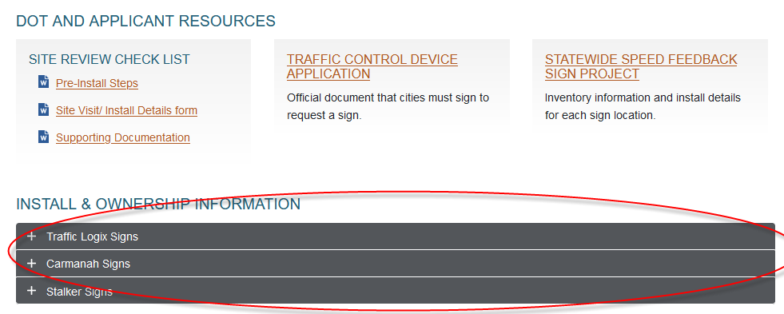

TAS: Update DOT Spreadsheet (on Sharepoint) with install date & notify Hossein with locations, placement date & operation start dates.
District (Traffic Tech): Notify the city that the installation is finished and that the signs are now theirs to own and maintain. Include copies of the owner’s manual & warranty information found here: https://iowadot.gov/traffic/speedfeedbacksigns

