Iowa Airport Land Use Guidebook

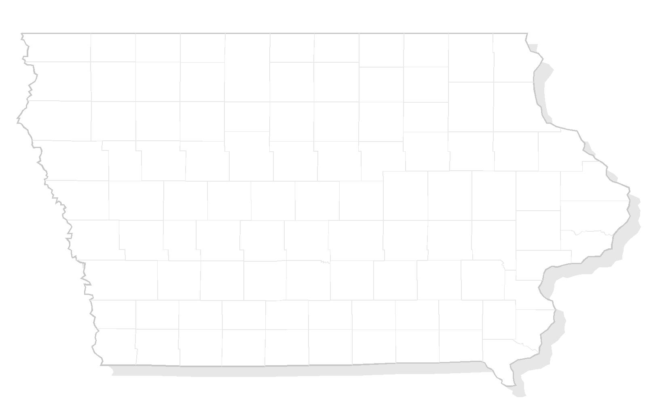

APPENDIX I
DISCLOSURE TO REAL ESTATE BUYER

THIS PAGE INTENTIONALLY LEFT BLANK

Sample – Disclosure to Real Estate Buyer

Customarily, someone will request a letter from the municipality about outstanding charges and assessments against a property. Something similar to this language, adapted for your airport, can be incorporated into a letter sent to buyers and title companies in preparation for closing.

This indenture made this _____ day of ____________________, 20____, by ____________________ and between __________________________, hereinafter referred to as Grantor, and ________________ County, a municipal corporation organized and existing under the laws of the State of Iowa, hereinafter referred to as Grantee, witnesseth:

WHEREAS the Grantor is the owner in fee of a certain _________________ parcel of land in the County of _________________, State of Iowa; and

Please be advised that the ____________ parcel of property is located within the height restriction zone of the _____________________ Airport, and/or is located within a similar distance from the airport.

WHEREAS it is conceivable that standard flight patterns would result in aircraft passing overflight (or nearly so) to the property at altitudes of less than ____________ feet.

Current _________________ Airport use patterns suggest that the average number of takeoffs and landings exceeds ____________ annually. The property buyer of aforementioned parcel number _______________should be aware that air traffic use patterns vary greatly, with the possibility of increased traffic on _____________________.

WHEREAS the _______________________ Airport presently serves primarily _____________________ aircraft, and there are no current initiatives to extend any runway beyond the current __________________ length. Airport plans allow for runway extension in the future, which might impact the number and size of both pleasure and non-pleasure aircraft.

THEREFORE, generally it is not practical to redirect or severely limit airport usage and/or planned-for expansion, and residential development proximate to the airport ought to assume, at some indefinite date, an impact from air traffic.”

Grantee, its successors and assigns, shall have and hold said easement and all rights appertaining thereto until said airport shall be abandoned and shall cease to be used for airport purposes.

IN WITNESS WHEREOF, the Grantor has hereunto set its hand and seal the day and year first above written.

____________________________________ (SEAL)

____________________________________ (SEAL)

NOTARY ACKNOWLEDGEMENT

STATE OF IOWA

COUNTY OF ________________________

Personally, came before me, this _________ day of _____________, 20____.
_______________________ and _______________________________ of the above named Corporation, to me known to be the person who executed for foregoing instrument and to me known to be such __________________________ and ______________________________ of said Corporation, and acknowledged that they executed the foregoing instrument such officers as the deed of said Corporation, by its authority.

__________________________________________
Notary Public, State of Iowa

My Commission Expires ______________________

