Iowa Airport Land Use Guidebook

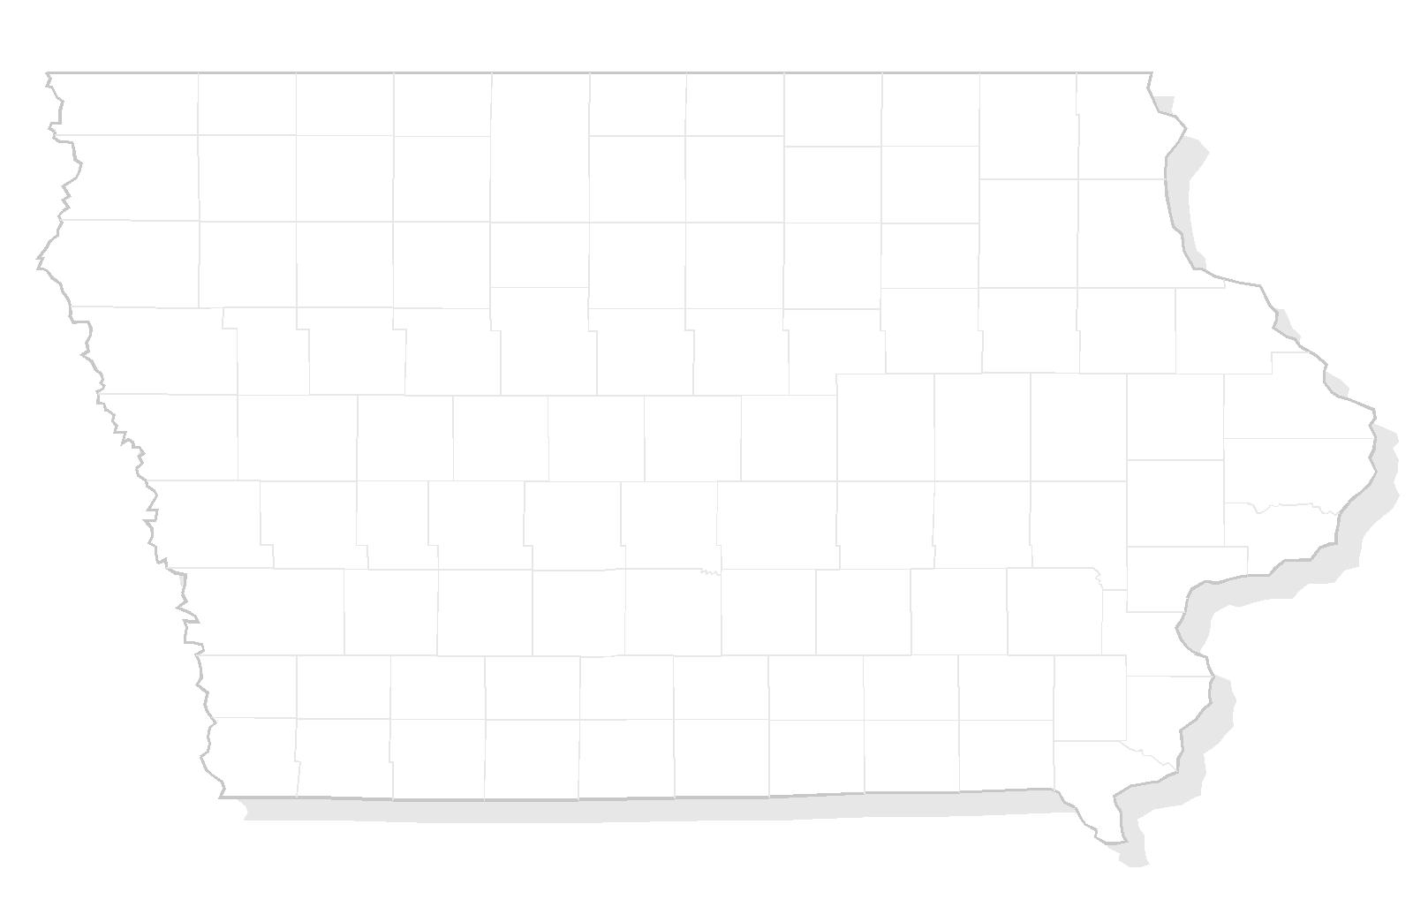

APPENDIX J
COMPATIBLE LAND USE PLANNING CHECKLIST

THIS PAGE INTENTIONALLY LEFT BLANK

Sample – Compatible Land Use Planning Checklist & Permit Application

CONTACT INFORMATION
Applicant Information
Name
Contact
Address
City/State/Zip
Phone
Fax

Engineer/Architect Information
Name
Contact
Address
City/State/Zip
Phone
Fax

STRUCTURE INFORMATION
Type of Construction
__________ New Construction __________ Alteration Ground Elevation ______________ (MSL)
__________ Permanent __________ Temporary Height of Structure + ______________ (AGL)
Top Elevation = ______________ (MSL)
Description and Use of Structure (dimensions, type of construction, purpose, etc):

SITE INFORMATION
Site Address Township
City/State/Zip Section
Nearest Road Intersection Latitude
Longitude

DRAWING INFORMATION
Request will not be considered without an engineered drawing/plan set which illustrates the following:
__________ Drawing Identification (file name or #) and Date __________ Engineers Seal
__________ Scale __________ Contact Information
__________ Site Map __________ Profile View of Structure
REMARKS

CERTIFICATION
I hereby certify that all statements on this application are true and correct
Signature Date
Name and Title of Person Filing the Notice
Phone of Person Filing Notice

OFFICAL USE ONLY

Site Location __________ Zone A __________ Zone B __________ Zone C
__________ Zone D __________ Zone E

Elevation Information Ground Elevation at Site _________________
Height of Structure _________________
Top Elevation _________________
Allowable Elevation _________________

IDENTIFY CURRENT AND POTENTIAL COMPATIBILITY CONCERNS

The purpose of this step is to begin to understand and identify airport land use compatibility concerns, both issues that already exist and ones that may arise if current airport activity and land use development patterns persist into the future.

- To what extent are generally recognized types or compatibility concerns apparent locally?
- How does the community feel about these concerns?
- What land use or airport-related actions are being taken to minimize the concerns?

Issues to Consider

- Noise sensitivity related issues
    - Extent of noise impact in relation of the airports environs
    - Anticipated growth of airport
    - Extent of soundproofing
    - Extent of sound barriers

- High concentrations of people
    - Number of people in a given area at one time
    - Anticipated growth of the development
    - Type of development and location of development relative to the runway ends and runway centerlines

  - Tall structures
    - Height of structure
    - Location of structure relative to the runway ends and runway centerlines
    - FAA Form 7460

  - Visual obstructions
    - Amount of dust, glare, light emissions, smoke, steam, or smog the development will emit
    - Location of lighting fixtures relative to the runway ends and runway centerlines
    - Glare or reflection from glass windows or open water bodies such as retention ponds

  - Wildlife and bird attractants
    - Select and space vegetation species to minimize habitats
    - Maintain appropriate grass lengths to minimize wildlife attractants
    - Prohibit certain agricultural crops near airport
    - Eliminate standing water
    - Use of repellents to disperse wildlife in a humane manner

Resources for Identifying Compatible Land Uses

- Iowa Department of Aviation Office of Aviation
  - Iowa Airport Land Use Guidebook
  - Staff
- Local municipal zoning
  - Airport overlay zoning ordinance
  - Height limitation zoning ordinance
- Federal Aviation Administration
  - Regulations
    - FAR Part 77 standards for airspace protection
    - FAR Part 150 noise compatibility study guidance
  - Advisory Circulars
    - Land use compatibility
    - Wildlife hazards
    - Model zoning ordinance
  - Various pamphlets and other materials
  - FAA and other state and federal web sites

DEVELOP COMPATIBILE CRITERIA

This step includes the process to determine the compatibility of the development relative to the airport.

Identify Primary Areas of Interest

- Noise Sensitivity Related Issues
- Safety Related Issues
  - High concentrations of people
  - Tall structures
  - Visual obstructions
  - Wildlife and bird attractants

Noise Sensitivity Related Issues

YES | NO | MAYBE | LAND USE CONCERNS
- Could the land use exceed compatible DNL noise levels of 65 or greater?

If YES, then consider the following items:

- Can the structure/land use be insulated to reduce noise impacts?

- Are there outdoor activities that would be impacted by noise events?

- Can landscaping material be utilized to mitigate possible noise exposure?

- Can the structure and/or land use be shifted within the site to allow a more compatible location?

- Other:

High Concentrations of People

YES | NO | MAYBE | LAND USE CONCERNS
- Could the land use attract a concentration of people?

If YES, then consider the following items:

- What is the size of concentration of people?

- What is the frequency of use at any given time?

- Are there outdoor activities associated with the use?

- Can the structure and/or land use be shifted within the site to allow a more compatible location?

- Other:

Tall Structures

YES | NO | MAYBE | LAND USE CONCERNS
- Could the land use exceed height standards?

If YES, then consider the following items:

- Can the structure and/or land use be lowered?

- Can the structure and/or land use be shifted within the site to allow a more compatible location?

- The applicant MUST submit an FAA Form 7460 to the FAA.

- Response from the FAA regarding Form 7460 is attached to the report for reference. However, FAA determination does not guarantee local approval.

- Other:

Visual Obstructions

YES | NO | MAYBE | LAND USE CONCERNS
 | ss |  | - Could the land use cause light or glare reflection upward?  If YES, then consider the following items:  - Can installation of down shielded light fixtures be utilized?  - Can the number of lighting fixtures be reduced while still illuminating the land use area?  - Can lighting be configured in a linear manner such that it does not align with a runway or airport facility making it difficult for a pilot to distinguish?  - Can reflective building materials (such a mirrored/reflective glass, solar panels, metal roofs, etc) be limited within the vicinity of an airport?  - Can areas of water be located away from the airport, due to possible reflection concerns?  - Other:

YES | NO | MAYBE | LAND USE CONCERNS
- Could the land use create or emit smoke, steam, or dust?

If YES, then consider the following items:

- Can the structure and/or land use be shifted within the site so that the prevailing wind directions carries the smoke, steam, or dust away from the airport to allow a more compatible land use?

- Can the land use activity be changed to reduce/limit emissions of smoke, steam, etc.?

- Land uses that create or emit smoke and steam generally contain stacks that could also be a height concern. (See height standards above)

- Other:

Wildlife and Bird Attractants

YES | NO | MAYBE | LAND USE CONCERNS
- Could the land use have or create areas of standing water?

If YES, then consider the following items:

- Does the standing water have wildlife controls in place such as wires, balls, etc across the water body that detracts birds from landing, roosting, or resting in the vicinity of an airport?

- Can the detention area be constructed in such a manner that standing water is dispersed within 48 hours?

- If the standing water is associated with a detention area, can the detention area be located under ground or have the depth increased to reduce surface area?

- Other:

Additional Considerations

YES | NO | MAYBE | LAND USE CONCERNS
- Could the land use contain flammable substances or materials?

If YES, then consider the following items:

- Can the structure and/or land use be shifted within the site to allow a more compatible location?

- Other:

YES | NO | MAYBE | LAND USE CONCERNS
- Could the land use cause a source of electrical, navigational, or radio interference?

If YES, then consider the following items:

- Has the applicant coordinated with the FAA, through the FAA Form 7460 to evaluate potential concerns?

- Has the response from the FAA regarding Form 7460 been received? (attach to report for reference)
(FAA determination does not guarantee local approval)

- Other:

Land Use Concerns Number of YES’s _______________
Number of NO’s _______________

Findings

Recommendations

Approved
□ YES □ NO
Administrator Name: Date

