Procedure for Beginning V8 Projects

- Copy the appropriate seed file (English or Metric) (Final or Preliminary) to create the project file using the SeedCreator application.
- brgEngSheet.dgn - English project final design seed file.
- brgMetSheet.dgn - Metric project final design seed file.
- brgPreEngSheet.dgn - English project preliminary design seed file.
- brgPreMetSheet.dgn - Metric project preliminary design seed file.
- Name the file appropriately for the project. See MicroStation V8 File and Model Naming Convention document.

Preliminary Design

- Open the created file in MicroStation.
- In the Models dialog box open the Structures model by double clicking the model Type icon.
- Open the References dialog box and reference in the appropriate models from the related road design files. Specific information on model usage can be obtained from the Office of Design.
- In the Models dialog box select the TSL_CC_DDDD model seed.
- Click on the Edit Model Properties tool.
- Rename the TSL_CC_DDDD model to the appropriate County leaving the DDDD. This model will become the seed model for that county.

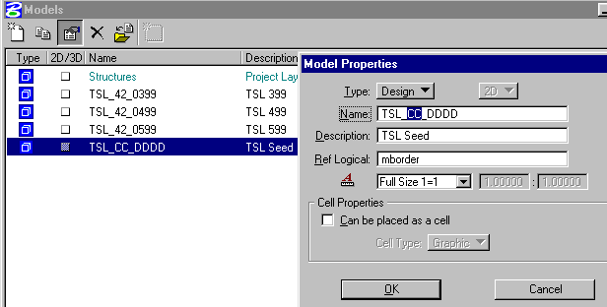

- Click on the OK button.
- In the Models dialog box open the TSL_CC_DDDD model by double clicking the model Type icon.
- Fill in the appropriate information and edit as necessary to set up a seed model for the TSL models.
- In the Models dialog box select the TSL_CC_DDDD model seed.
- Click on the Copy a model tool.

- Rename the new TSL model with the appropriate design number and modify description.

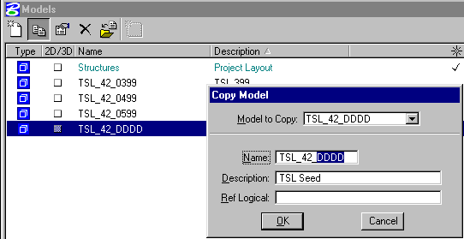

- Click OK button.
- Open the new TSL model by double clicking the model Type icon.
- Complete the TSL model as appropriate for that structural design.
- Repeat steps 10 to 15 for the TSL models needed for the project.
Final Design

- Open the created file in MicroStation.
- In the Models dialog box select the bdr model.
- Click on the Edit Model Properties tool.
- Rename the bdr model to the appropriate County and Design Number.

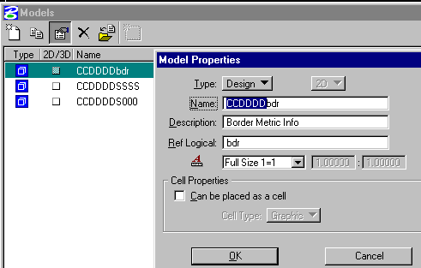

- Click OK button.
- In the Models dialog box open the bdr model by double clicking the model Type icon.
- Fill in the appropriate project information.
- In the Models dialog box select the S000 Title Sheet model.
- Click on the Edit Model Properties tool.
- Rename the Title Sheet model to the appropriate County and Design Number.

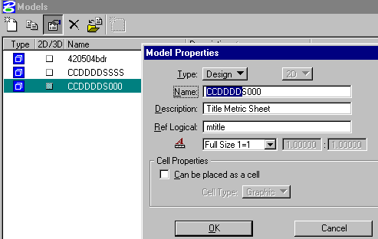

- Click OK button.
- In the Models dialog box open the Title Sheet model by double clicking the model Type icon.
- Complete the Title Sheet as appropriate.
- In the Models dialog box select the Detail Sheet Seed model.
- Click on the Edit Model Properties tool.
- Rename the seed model to the appropriate County and Design Number leaving the SSSS.

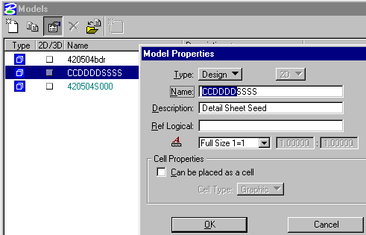

- Click OK button.
- Open this renamed Detail Sheet Seed model by double clicking the model Type icon.
- Open the References dialog box and reference the renamed bdr model.
- Use the following settings in the Reference Attachment Settings dialog box.
- Nested Attachments: set to Live Nesting
- Depth: set to 2.

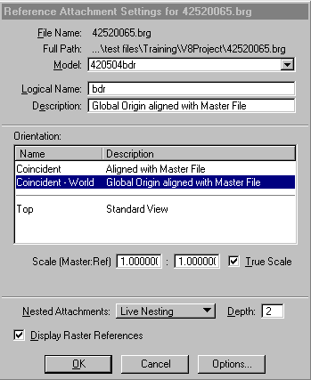

- Click OK button.
- In the Models dialog box select the Detail Sheet Seed model.
- Click on the Copy a model tool.
- Rename the new model with the appropriate sheet designation to replace the SSSS and modify description.

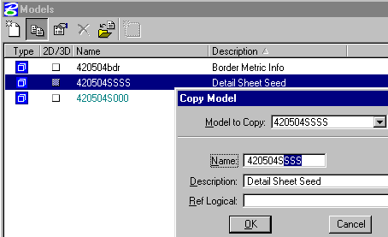

- Click OK button.
- Open the new detail sheet model by double clicking the model Type icon.
- Complete the detail sheet as appropriate.
- Repeat steps 16 to 21 for the detail sheets needed for the project.

For multiple counties and/or multiple design numbers used in a project, the reuse of the seed models may be more efficient if a copy is made prior to any modification. Then a seed model can be set up with the appropriate partial name, information, and/or referenced files for each separate situation. This applies to the seed for the TSL_CC_DDDD model for Preliminary Design, and the bdr model and Detail Sheet Seed model for Final Design.

Labeling multiple counties on the Detail Sheets and Title Sheet –
- Assume County#1 is Butler (12) and County#2 is Grundy (38) and the Project Number lists the Butler (12) County number.
- Assume the Structure is in Grundy (38) County.
- Use both county names in the bottom border information shown as Butler (Grundy) County if the Structure is in Grundy County. If the Structure is in Butler County only show the bottom border information as Butler County.
- Use the county the Structure is located at in the Title block.
- Show Butler (Grundy) everywhere on the Title sheet.

Completion of Plan and Profile Sheet

- In the Models dialog box Click on the Import Models tool.
- Navigate to the appropriate preliminary design file containing the needed TS&L model.
- Click OK button.
- Select the model needed in the Select Models dialog box.

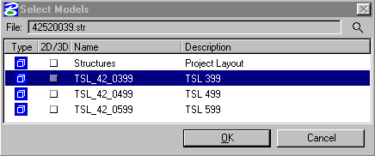

- Click OK button.
- In the Models dialog box select the imported model.
- Click on the Edit Model Properties tool.
- Rename the imported model to the appropriate County, Design Number, and sheet designation (s002p).

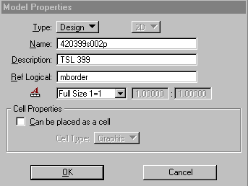

- Click OK button.
- Open the plan and profile model by double clicking the model Type icon.
- Complete as appropriate.

Completion of detail sheets may involve importing models from seed files. The example of importing the revision sheet is shown below. The seed files are located at W:\DOTCadd\SeedFiles\Bridge\ and in Project Wise at –PWMain\Documents\Standards\DOTCadd\SeedFiles\Bridge\

- In the Models dialog box Click on the Import Models tool.
- Navigate to the appropriate file containing the needed model.
- brgSeed.dgn – English file holding all seed models.
- brgMSeed.dgn – Metric file holding all seed models.
- Click OK button.
- Select the model needed in the Select Models dialog box.

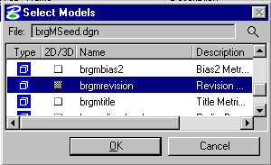

- Click OK button.
- In the Models dialog box select the imported model.
- Click on the Edit Model Properties tool.
- Rename the imported model to the appropriate County, Design Number, and sheet designation.

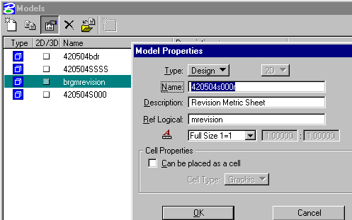

- Click OK button.
- Open the imported model by double clicking the model Type icon.
- Complete the detail sheet as appropriate.

