MicroStation V8 Levels

The levels used for V8 projects files are provided in the level library, BridgeLevels.dgnlib. To ease use of the levels, filters are provided to display only those levels you will need. Besides the office filter providing all levels named with the brg office prefix, six additional filters are provided. The filter names and how they are created are listed in the table below.

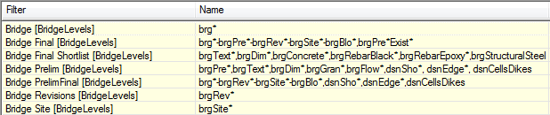

The levels are shown below through views of Level Manager organized by filter. The color, style, weight, priority, and transparency of the levels are provided.

Bridge Final Filter

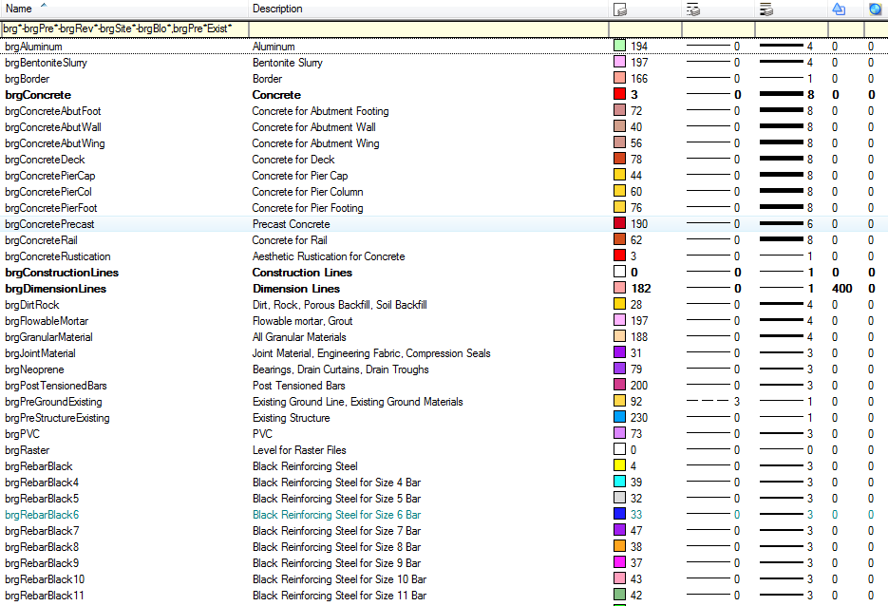
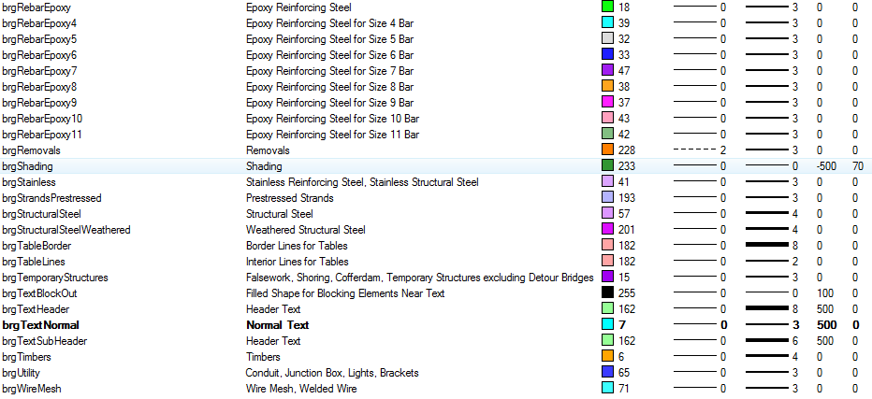

Bridge Final Shortlist Filter

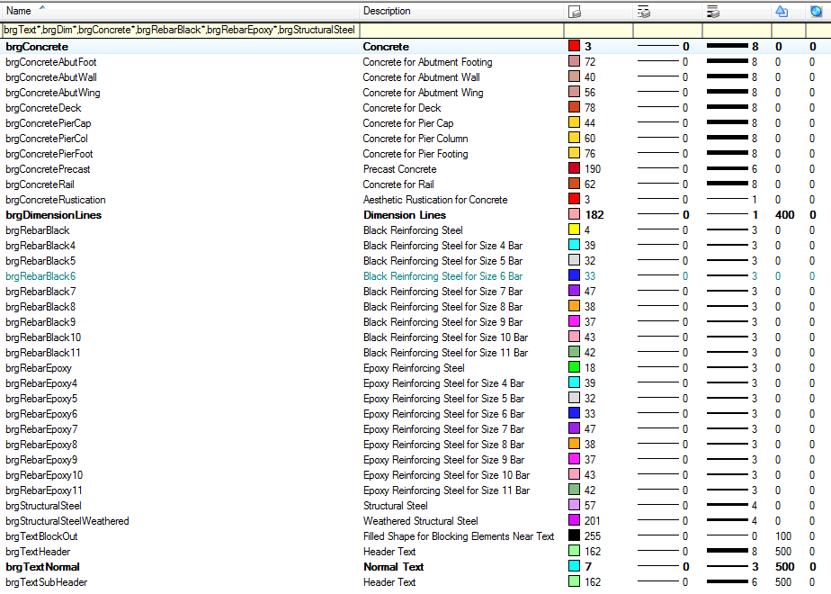

Bridge Prelim Filter

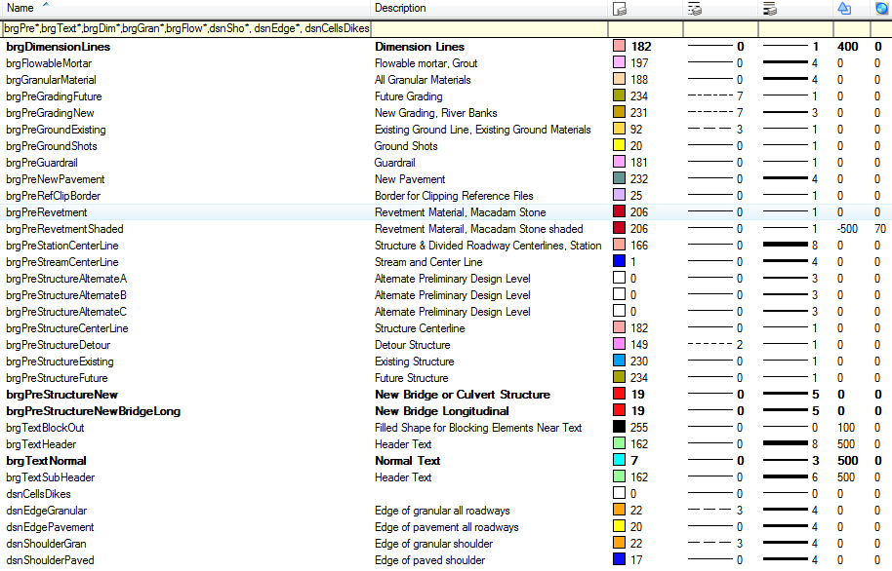

Bridge PrelimFinal Filter

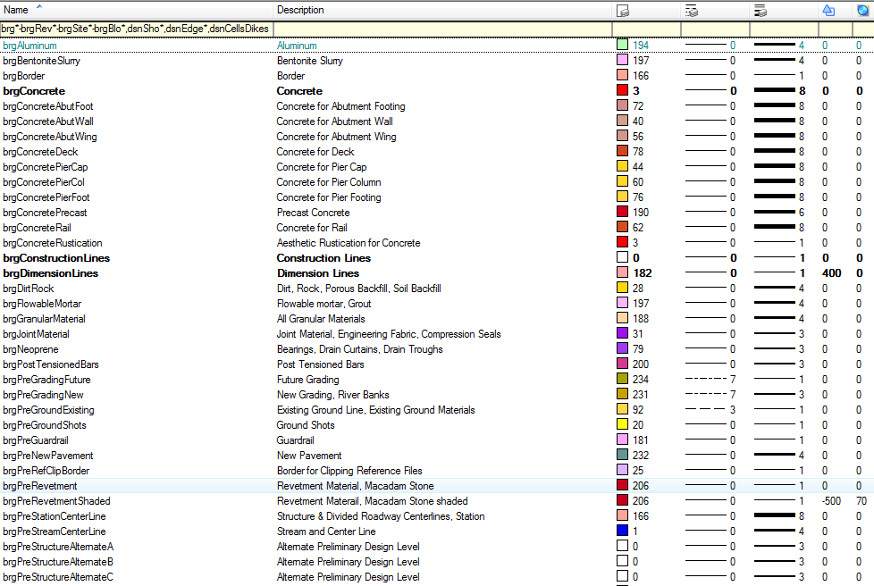
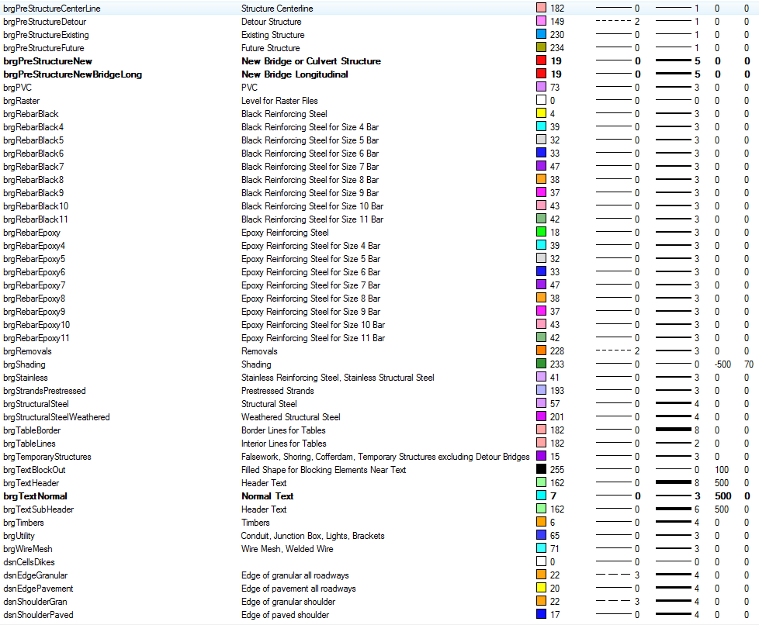

Bridge Revisions Filter

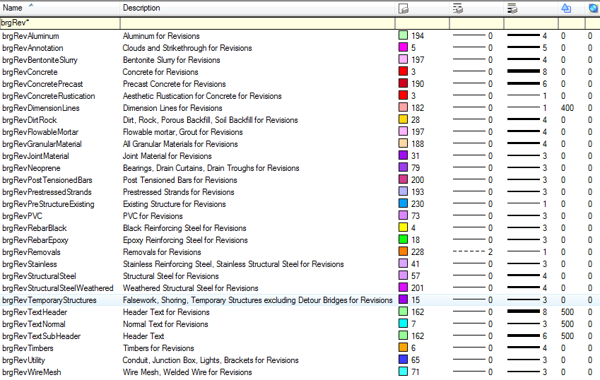

Bridge Site Filter

