SHADES and PLANT REPORT Notes
8/9/2010
MINIMUM REQUIREMENTS
Both SHADES and the Plant Report are macro-enabled excel 2007 workbooks (.xlsm). Microsoft Excel 2007 or higher will be required. Please follow the instructions on enabling macros and solver in excel.
ENABLING MACROS
Excel 2007/2010 Users
  - Open Excel
  - Click Developer and Macro Security
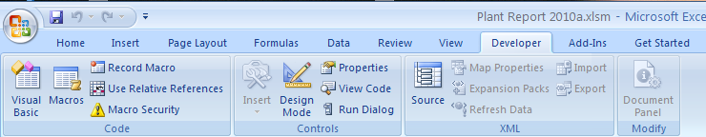
  - Select either “Disable all macros with notification” OR “Enable all macros”
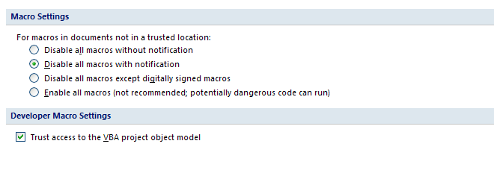
  - Open the workbook
  - If you see the following message, click “Enable Macros”
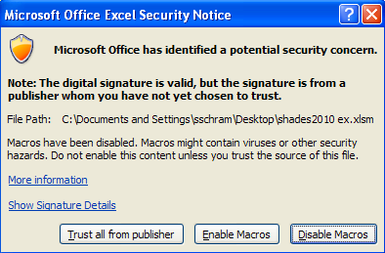
  - If “Disable all macros with notification” is selected in part c, when clicking on a button (for example the “Export” button as shown below”), you may receive the following message: “Cannot run the macro “Plant Report 2010”. The macro may not be available in the workbook or all macros may be disabled.”
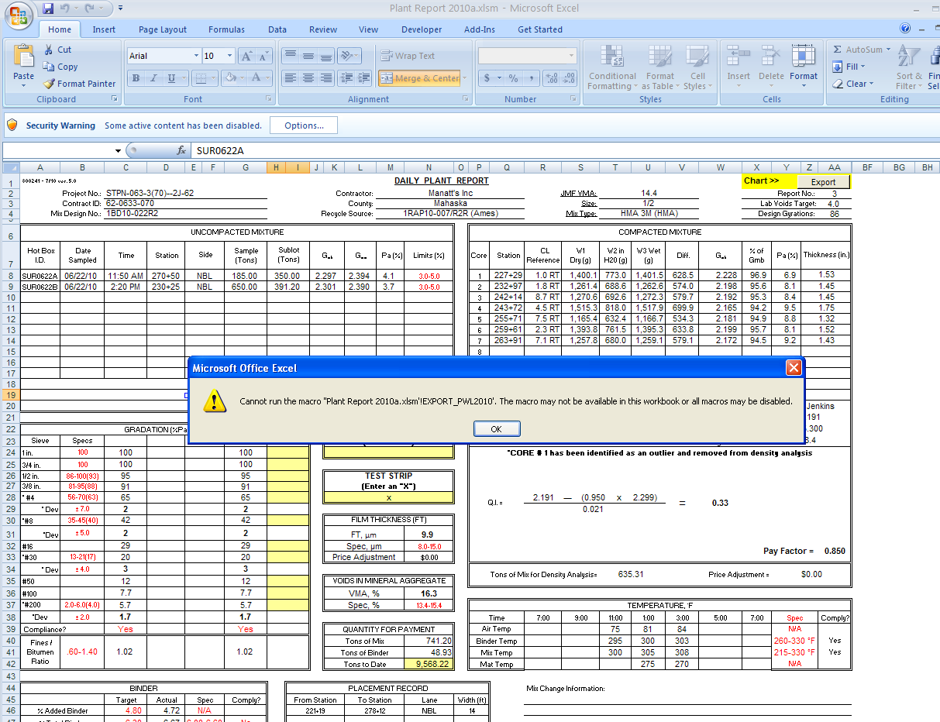
  - Click OK
  - Open Security Options
  - Select “Enable this content”
  - Click OK (See image below)
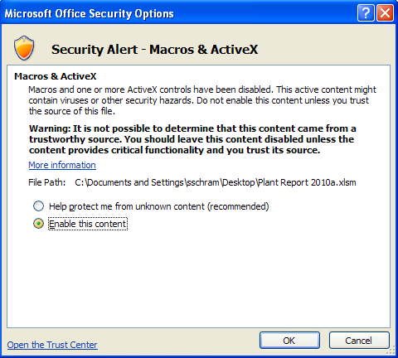
ENABLING SOLVER
Solver is required. To enable, follow the excel options > Add-ins > Manage Add-ins (Go button) > Check Solver.
VERY IMPORTANT FINAL STEP: CLOSE EXCEL AND RE-OPEN
