Template Version 1.1
REV: January 2023

Interchange
Justification Report for
{Project Name}

{County, Iowa}

Project Number {IMN-XXX-X(XXX)XX—XX-XX}

Prepared for:

{Month Day, Year}

Instructions for Using Template
Use this template as a starting point for writing an Interchange Justification Report (IJR) related to an access change request. This template provides materials to be supplied in all IJRs and in the order in which the materials are to be presented. The user is encouraged to follow this template as strictly as possible to provide consistency for documentation. The Iowa Department of Transportation recognizes that every project is unique, and modifications to template materials and organization of materials may be necessary to meet the unique characteristics of a project. This template should be used in conjunction with the Iowa DOT User Guide for New or Revised Interchange Access. Sections 3.1 and 4.4 of the Iowa DOT User Guide for New or Revised Interchange Access provide guidance pertaining to the IJR.
The page layout for this template is generally 8 ½” x 11” portrait, and this should be maintained by the user. It may be appropriate to provide figures or tables on pages that are 11” x 17” landscape.
Text in this template is color-coded to identify user inputs, instructions and standard text, as follows:
- Text highlighted yellow is a user input. This text should be replaced with the appropriate text or value, and the highlight should be removed.
- Text in {brackets} is also a user input. This text is part of a heading or title, and the formatting of this text should not be altered. Text in {brackets} on the following title page is referenced to text on the cover page. This text should be updated by right-clicking on the text.
- Text in bold/orange is instructional to help the user complete the document. This text should be deleted from the document once the user has followed the instructions provided by this text.
- Text that is bold/red is a reference to a table or figure. This format should be used for all references to tables and figures.
- Text that is black or a hyperlink is standard text that should generally not be edited.
Example tables and figures are provided in this template. These tables and figures should be populated, replaced or deleted as appropriate. Table and figure title numbers are set up to reference the appropriate section of the document and the appropriate table or figure number within each section. The reference to tables and figures within the body of the document is cross-referenced to the table or figure title. When adding tables or figures, the user should match the formatting of provided tables and figures (including table/figure titles and references within the body). When adding or removing tables or figures, the provided table and figure title numbers and references within the body should be updated.
Page breaks are inserted at the end of each main section and at locations within sections for readability of the template. Page breaks between main sections should be maintained. The user should remove page breaks within main sections where appropriate.
Double-click in the header and Word will automatically update the project name and date after filling out the cover page.
The lists for Contents, Tables and Figures on the following page(s) should be updated after completing the document.
This page is to be deleted prior to submittal.
{Project Name}
{County, Iowa}

Project Number
{IMN-XXX-X(XXX)XX—XX-XX}
This document has been prepared to obtain Federal Highway Administration approval for new or revised interchange access on the Interstate System.
Interchange Justification Report
Prepared by
Agency or Company
For
The Iowa Department of Transportation and Federal Highway Administration
{Month Day, Year}
Replace Seal | I hereby certify that this engineering document was prepared by me or under my direct personal supervision and that I am a duly licensed Professional Engineer under the laws of the State of Iowa.  Add Signature MM/DD/YYYY  JOHN SMITH, P.E. (date)  License No. XXXXX  My license renewal date is December 31, YYYY  Pages of sheets covered by this seal:  List Pages

District X Office/Highway Division
Address l City, State Zip
Phone: XXX-XXX-XXXX l Email: Email@iowadot.us

Following review and approval of the IJR by the Iowa DOT District Engineer, a letter of approval by the District Engineer for the IJR is sent via email to the FHWA, Iowa Division for approval. This email is sent to Iowa.FHWA@DOT.gov. Typically for this action, a ProjectWise link to the final IJR is sent to FHWA with this letter of approval attached to the email. Once the FHWA has approved the IJR, the FHWA will submit a letter of approval for the IJR. The letters of approval by the Iowa DOT and FHWA should be filed with the final IJR that is signed and approved.
This page should be used as a guide when preparing the Iowa DOT letter of approval. Remove this page from the IJR document that is submitted for reviews.
Month Day, Year

Program Delivery Team Leader
FHWA, Iowa Division
105 6th Street
Ames, Iowa 50010

Subject: Project Name Interchange Justification Report
Project Number IMN-XXX-X(XXX)XX—XX-XX

Dear Program Delivery Team Leader,

I have approved this Interchange Justification Report, dated Month Day, Year for Engineering Operations and I am submitting it to FHWA for approval.

Sincerely,

Add Signature

Name
District X Engineer

Contents
Executive Summary 1
1 Introduction 2
1.1 Project Location 2
1.2 Project Background 3
1.3 Project Purpose 3
2 Methodology 4
2.1 Area of Influence 4
2.2 Analysis Years/Scenarios and Periods 5
2.2.1 Operational Analysis Years/Scenarios and Periods 5
2.2.2 Safety Analysis Scenarios 6
2.3 Traffic Forecasting Methodologies 6
2.4 Operational Analysis Methodologies 6
2.4.1 Software Input Assumptions and Methodologies 7
2.4.2 Performance Measures 7
2.4.3 Microsimulation Model Calibration and Number of Runs 8
2.5 Safety Analysis Methodologies 8
2.6 Geometric Design Criteria 9
2.6.1 Anticipated Design Exceptions 9
3 Existing Conditions 10
3.1 Existing Roadway Network 10
3.2 Existing Alternative Travel Modes 10
3.3 Existing Traffic Volumes 10
3.4 Existing Conditions Operational Analysis 11
3.5 Existing Conditions Crash Analysis 14
4 Future Year No-Build Conditions 17
4.1 Adjacent Planned Roadway Improvements 17
4.2 Design Year 20XX No-Build Conditions Traffic Forecasts 17
4.3 Design Year 20XX No-Build Conditions Operational Analysis 18
5 Problem Definition 19
6 Alternatives 20
6.1 Reasonable and Feasible Alternatives 20
6.2 Build Alternatives 20
7 Alternatives Analysis 22
7.1 Design Year 20XX Build Conditions Traffic Forecasts 22
7.2 Design Year 20XX Build Conditions Operational Analysis 23
7.3 Design Year 20XX Build Conditions Predictive Crash Analysis 23
7.4 Alternatives Evaluation Summary and Selection of Preferred Alternative 24
7.5 Preferred Alternative Guide Sign Layout 24
7.6 Opening Year 20XX Build Conditions Operational Analysis 26
7.7 Interim Year 20XX Build Conditions Operational Analysis 26
8 Social, Economic and Environmental Reviews 28
8.1 Land Use and Transportation Plan Consistency 28
8.2 Coordination for Local System Improvements 28
9 Conclusions and Recommendations 30
9.1 Conclusions 30
9.1.1 FHWA Policy Review and Response 30
9.2 Recommendations 32
10 Appendix 34

Tables
Table 2-1. Freeway LOS Density Thresholds 7
Table 2-2. Intersection LOS Delay Thresholds 8
Table 3-1. Existing Conditions Freeway Operations 12
Table 3-2. Existing Conditions Mainline Segment Crash Rates 14
Table 3-3. Manner of Crash for Mainline Crashes 15
Table 3-4. Cause of Crash for Mainline Crashes 15
Table 7-1. Daily Volume Comparison between Existing and Design Year Conditions 22
Table 7-2: Predictive Crash Alternative Comparison 24

Figures
Figure 1-1. Project Location Map 3
Figure 2-1. Area of Influence 5
Figure 3-1. Existing Conditions Traffic Volumes 11
Figure 3-2. Existing Conditions Operations 13
Figure 4-1. Design Year 20XX No-Build Conditions Traffic Forecasts 17
Figure 6-1. Build Alternative Conceptual Layout 21
Figure 7-1. Preferred Build Alternative Guide Sign Layout 25
Figure 7-2. Opening Year 20XX Build Conditions Traffic Forecasts 26

This page is intentionally left blank.

Executive Summary
This Interchange Justification Report (IJR) provides documentation of engineering and operations to justify new or revised access on Interstate facility at crossroad (mile marker) in County, Iowa, in fulfillment of the Federal Highway Administration (FHWA) Policy on Access to the Interstate System. The proposed access change would describe the changes that would be made by the proposed access change. The access change request is being made to state the goals and objectives of the proposed access change.
Summary of existing, No-Build and Build conditions.
Provide a summary of results for traffic forecasts, operational analysis and safety analysis completed for existing, No-Build and Build conditions. This summary should be similar to the summary provided in the Conclusions section of this IJR.
The FHWA Policy requirements have been addressed through reviews and evaluations completed in this IJR. The Policy requirements and responses are provided in the Conclusions and Recommendations chapter of this IJR. A summary of the FHWA Policy responses is provided below:
- FHWA Policy (2017) Requirement 1 response: Response.
- FHWA Policy (2017) Requirement 2 response: Response.
In the bullet list above, include a bullet for each of the requirement responses provided in the Conclusions section of the IJR. For FHWA Policy requirements addressed in a NEPA or other approved planning study, such as a Location Study, do not provide a bullet in the list above.
Recommendations for the proposed access change.
Provide recommendations for the proposed access change based on the evaluations and conclusions documented in the IJR Amendment. The recommendation text should be similar to the recommendations provided in the Recommendations section of this IJR Amendment.

Introduction
This Interchange Justification Report (IJR) provides documentation of engineering and operations to justify new or revised access on Interstate facility at crossroad (mile marker) in County, Iowa, in fulfillment of the Federal Highway Administration (FHWA) Policy on Access to the Interstate System. The proposed access change would describe the changes that would be made by the proposed access change. The access change request is being made to state the goals and objectives of the proposed access change. The engineering and operations documented in this IJR are provided through operational and safety evaluations, conclusions, and recommendations.

Project Location
The project is located describe the project location in relation to surrounding communities and nearby features or facilities. Example of project location description for example graphic provided in Figure 1-1 below: The project is located at the I-80 / 1st Avenue interchange in eastern Coralville, Iowa, immediately west of the Iowa River. The location of the project is shown in Figure 1-1 in relation to surrounding communities and facilities. Intersections or interchanges immediately adjacent to the project include:
- West Adjacent Intersection/Interchange.
- East Adjacent Intersection/Interchange.
- South Adjacent Intersection/Interchange.
- North Adjacent Intersection/Interchange.
Provide additional description of the project area and surrounding features or land uses.
Figure 1-1. Project Location Map
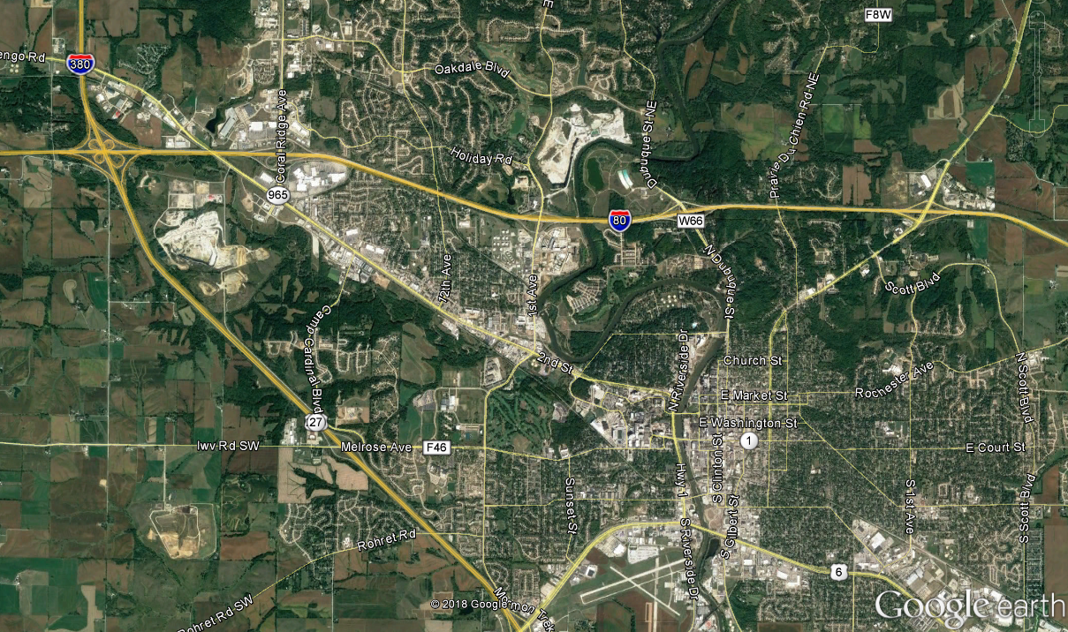
Iowa City
Coralville
Oakdale
Project Location
N
(Replace this example graphic with project location graphic)
The figure used to show the project location should include an area of sufficient size to identify the project area in relation to surrounding communities and nearby features or facilities.

Project Background
Project background.
Describe the history of the project, including past studies or improvements that may have led to the proposed access change. Reference local, regional and statewide planning documents that include the project and funding sources identified. For projects that are not in a planning document, describe the steps being taken to have the project added in local/regional/state planning documents.

Project Purpose
Project purpose.
Briefly describe the purpose of the project, stating the goals and objectives to be achieved by the proposed access change.

Methodology
The methodologies used to evaluate traffic operations and safety, and design criteria used in developing the alternative or alternatives are provided in the following sections.

Area of Influence
The area of influence for operational and safety analyses is shown in Figure 2-1. The area of influence includes freeway mainline, ramps, ramp terminal intersections and crossroad intersections within the following boundaries:
- West limits: XXXXX.
- East limits: XXXXX.
- South limits: XXXXX.
- North limits: XXXXX.
Example of boundary summary for example graphic in Figure 2-1:
- West limits: West ramp junctions of the I-80 / Coral Ridge Avenue interchange (Exit 240).
- East limits: East ramp junctions of the I-80 / Dubuque Street interchange (Exit 244).
- South limits: 1st Avenue / E 7th Street intersection.
- North limits: 1st Avenue / Holiday Road intersection.
Provide additional details to clearly define the area of influence as appropriate.

Figure 2-1. Area of Influence
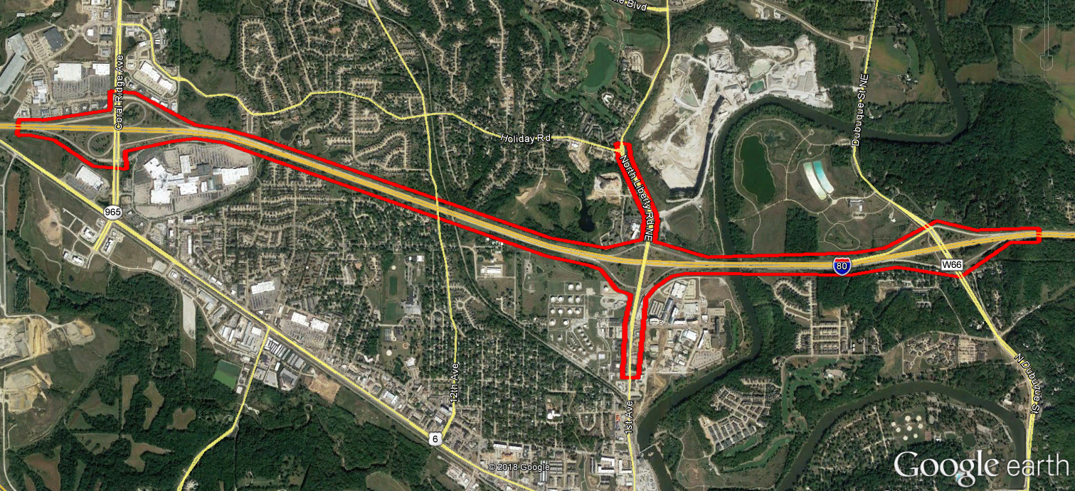
N
Area of Influence
(Replace this example graphic with project area of influence graphic)

Analysis Years/Scenarios and Periods

Operational Analysis Years/Scenarios and Periods
The following years/scenarios were evaluated for traffic operational analysis:
- Existing (base) year 20XX.
- Design year 20XX No-Build.
- Design year 20XX Build Alternative Name. Provide a separate bullet for each Alternative evaluated for the design year. Provide additional description for each Alternative as needed to differentiate between the Alternatives.
- Opening year 20XX Build Alternative Name.
- Interim year 20XX Build Alternative Name. Remove this bullet if not included for the traffic operational analysis. Provide a separate bullet for each interim year evaluated.
Operational analysis was completed for periods of each scenario. (e.g., AM and PM peak hours). It may be necessary or beneficial to show existing data to support determination of the period durations, such as ATR or INRIX speed data.

Safety Analysis Scenarios
The following scenarios were evaluated for traffic safety analysis:
- Existing crash analysis for the most recent number of years years of crash data (years 20XX-20XX). Number of years is typically a minimum of five years.
- Predictive crash analysis for design year 20XX No-Build. Remove this bullet if not included for the traffic safety analysis (No-Build predictive crash analysis may only be necessary when comparing predicted crashes to Build alternatives).
- Predictive crash analysis for design year 20XX Build Alternative Name. Provide a separate bullet for each Alternative evaluated for the design year.

Traffic Forecasting Methodologies
Existing conditions traffic volumes were developed from traffic counts, vehicle classification data and origin-destination data obtained for this project. Existing conditions traffic data was obtained from state the sources and methodologies for obtaining existing conditions data. Modify or add to the methodology for developing existing conditions traffic volumes as appropriate. It may be necessary or beneficial to provide the existing conditions data sources in a bullet list or table.
Traffic forecasts for design year No-Build and Build conditions were provided by source. Forecasts were based on state the Travel Demand Model(s) to be used and the horizon year for the Travel Demand Model(s), and utilized existing turning patterns, vehicle classification data and origin-destination data as appropriate. Modify or add to the methodology for developing design year forecasts as appropriate.
Traffic forecasts for opening year Build conditions were provided by source. State the methodology for developing opening year forecasts.
Traffic forecasts for interim year Build conditions were provided by source. State the methodology for developing interim year forecasts. Remove this paragraph if not included for the traffic operational analysis.
Traffic forecasts are provided in tables and/or figures later in this IJR in conjunction with traffic operational analyses.

Operational Analysis Methodologies
Operational analysis of locations within the area of influence was completed using list software and software version used for the operational analysis for the scenarios/periods outlined in Section 2.2.1.

Software Input Assumptions and Methodologies
Data, forecasts and conceptual layouts were used for inputs of geometry, traffic control, traffic volumes and travel speeds. Detailed assumptions on software input assumptions and methodologies are provided in the project Methods and Assumptions (M&A) document located in the appendix.
Provide additional details to summarize the software input assumptions and methodologies as appropriate.

Performance Measures
Summarize the performance measures used to report operational analysis results.
The outline of operational software results and performance measures provided in the M&A document should be used to populate this section. Level of service (LOS) is typically the primary performance measure reported from the operational analysis in an IJR. Provide a description of LOS and the freeway density / intersection delay thresholds for LOS. Example tables for LOS thresholds are provided below.
LOS thresholds for freeways are summarized in Table 2-1. LOS thresholds for intersections are summarized in Table 2-2.
Table 2-1. Freeway LOS Density Thresholds
Level of Service (LOS) | Freeway Segment Density (pc/mi/ln¹)
 | Basic Freeway Segment | Ramp Junction Area | Weave Segment
A | 0-11 | ≤ 10 | ≤ 10
B | >11-18 | >10-20 | >10-20
C | >18-26 | >20-28 | >20-28
D | >26-35 | >28-35 | >28-35
E | >35-45 | >35 | >35-43
F | >45 | Demand Exceeds Capacity | >43, or Demand Exceeds Capacity
Source: Highway Capacity Manual, 6th Edition.
¹ Passenger cars per mile per lane.

Table 2-2. Intersection LOS Delay Thresholds
Level of Service (LOS) | Control Delay (seconds/vehicle)
 | Signalized Intersection | Unsignalized Intersection
A | ≤ 10 | ≤ 10
B | >10-20 | >10-15
C | >20-35 | >15-25
D | >35-55 | >25-35
E | >55-80 | >35-50
F | >80 or V/C > 1.00 | >50 or V/C > 1.00
Source: Highway Capacity Manual, 6th Edition.

Microsimulation Model Calibration and Number of Runs
This section is only applicable for projects that include microsimulation modeling. For projects that do not include microsimulation modeling, delete this section (including the section heading).
Data and field observations were used to calibrate the existing conditions microsimulation models. The procedures outlined in the Iowa DOT Microsimulation Guidance document were used for model calibration and to determine the number of model runs to complete for each model. Ten model runs were completed for each model to produce a 95% confidence of achieving results within a maximum tolerable error of 10% of the average for a given performance measure. (Describe the process for completing simulation to produce results within a desired confidence and tolerable error.) Details of the microsimulation model calibration and determination for number of model runs are provided in the Calibration Memo located in the appendix.

Safety Analysis Methodologies
Safety analysis of locations within the area of influence was completed for the scenarios/periods outlined in Section 2.2.2. The methodologies and procedures outlined in the Iowa DOT Data Driven Safety Guidance document were used to complete the safety analysis. Existing crash analysis was completed by comparing recent historical crashes obtained from source to statewide averages and summarizing crash trends. Predictive crash analysis was completed using state the tool(s) or resource(s) used to predict the expected change in crashes between design year scenarios.
Provide additional details to describe the safety analysis methodologies as appropriate.

Geometric Design Criteria
Geometric design criteria were documented using the electronic form from the Iowa DOT Design Manual, Section 1C-1 for each roadway type within the area of influence.
List additional resources that were used in the development of design criteria, such as the Iowa DOT adopted versions of the American Association of State Highway and Transportation Officials (AASHTO) A Policy on Geometric Design of Highways and Streets or AASHTO Policy on Design Standards Interstate System, Highway Capacity Manual, or local City/County design standards. Provide any guiding principles or key features that supported development of the design criteria.

Anticipated Design Exceptions
Description of anticipated design exceptions
Provide descriptions of anticipated design exceptions. If no design exceptions are anticipated, provide a statement similar to, “No design exceptions are anticipated at this time based on current information.”

Existing Conditions
A summary of existing conditions are provided in the following sections. The existing conditions summaries are provided through documentation of the existing roadway network, alternative travel modes, traffic volumes, operations and safety.

Existing Roadway Network
List geometric features, safety features or facilities that are relevant to the project goals and objectives. The discussion of existing roadway network should typically be limited to one or two paragraphs. Provide graphics such as maps or photos to illustrate geometric features as appropriate. A sample description for existing roadway network is provided below.
The existing I-80 / 1st Avenue interchange is a diamond interchange with signalized ramp terminal intersections and dedicated left-turn lanes for all left-turn movements. To accommodate high traffic demand for turning movements, the westbound ramp terminal intersection includes dual westbound left-turn lanes, and the turn lanes from 1st Avenue onto the I-80 ramps have storage between 300’ and 400’. 1st Avenue over I-80 is a single bridge for vehicular traffic with a separate pedestrian bridge on the west side of the main bridge.

Existing Alternative Travel Modes
Describe the existing modes of transportation related to the project that are alternatives to passenger cars. These modes may include managed lanes (carpool or tolling lanes), park and ride facilities, bus transit, airports, ports, and forms of non-motorized transportation facilities. Provide graphics such as maps or photos to illustrate locations of alternative travel modes as appropriate. A sample summary of existing alternative modes is provided below.
Within the area of influence and along adjacent transportation facilities, alternative travel modes are limited to bus transit, sidewalks and trails. Bus transit through the area of influence is provided along 1st Avenue and over I-80. The Iowa River Corridor trail travels along the Iowa River and under I-80 just east of the 1st Avenue interchange. Sidewalk is provided on the west side of the 1st Avenue bridge over I-80.

Existing Traffic Volumes
The existing (year 20XX) traffic volumes within the area of influence are provided in Figure 3-1.
Provide additional details to describe the existing traffic volumes within the area of influence as appropriate. If existing conditions operational analysis results are displayed on a figure that also illustrates existing traffic volumes, it may be appropriate to move materials from this section into the Existing Conditions Operational Analysis section (a separate figure for existing conditions traffic volumes may then not be necessary). If existing traffic volumes details are provided in the Existing Conditions Operational Analysis section, delete this section (including the section heading).
Figure 3-1. Existing Conditions Traffic Volumes
Insert graphic for existing conditions traffic volumes
Provide a figure that shows existing traffic volumes throughout the area of influence, including daily volumes, peak hour/period movement volumes, weaving volumes and truck percentages as appropriate. It may be necessary to provide this figure as a standalone page depending on the size of the area of influence.

Existing Conditions Operational Analysis
Operational analysis was performed for existing (year 20XX) conditions for the state the periods (e.g., AM and PM peak hours) to determine the current operations within the area of influence. The results for existing conditions operational analysis are shown in list tables and figures. Duplicate the previous sentence if more than one tool is used for the operational analysis and specify the tool for each series of tables/figures.
Provide tables and/or figures to report results of the existing conditions operational analysis as appropriate. An example table and figure is provided below to illustrate example formatting (these examples are not meant to provide a full summary of what should be provided). Provide a summary of the results in paragraphs or bullets to supplement tables and figures, highlighting the overall operations within the area of influence, and noting locations with poor operations or other operational concerns.

Table 3-1. Existing Conditions Freeway Operations
(Specify software in table title if using more than one software tool)
Location | Segment Type | Density (pc/mi/ln) / LOS
 |  | AM Peak Hour | PM Peak Hour
I-80 Eastbound
At Coral Ridge Ave NB Entry | Ramp Junction | 17.4 / B | 19.3 / B
Coral Ridge Ave to 1st Ave | Basic Freeway | 16.3 / B | 17.7 / B
At 1st Ave Exit | Ramp Junction | 21.8 / C | 23.6 / C
1st Ave Exit to Entry | Basic Freeway | 14.1 / B | 14.6 / B
1st Ave to Dubuque Street | Weave | 16.7 / B | 17.4 / B
I-80 Westbound
Dubuque Street to 1st Ave | Weave | 12.3 / B | 15.9 / B
1st Ave Exit to Entry | Basic Freeway | 11.1 / B | 12.9 / B
At 1st Ave Entry | Ramp Junction | 15.8 / B | 17.2 / B
1st Ave to Coral Ridge Ave | Basic Freeway | 15.2 / B | 16.6 / B
At Coral Ridge Ave Exit | Ramp Junction | 17.1 / B | 23.9 / C
Source: HCS 7 Analysis, Agency or Company that conducted the analysis, Date.
(Remove or modify the table above as appropriate)

Figure 3-2. Existing Conditions Operations
(Specify software in figure title if using more than one software tool)
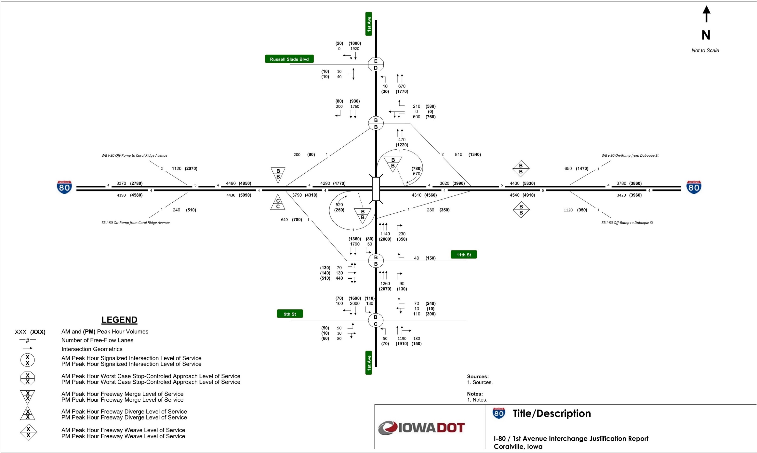
(Replace or delete the above figure as appropriate)

Existing Conditions Crash Analysis
Existing crash analysis was performed to determine current crash trends and/or concerns within the area of influence. Existing crash analysis was performed for Interstate facility mainline segments and intersections within the area of influence. Crashes were analyzed for the five-year period 20XX-20XX, using the crash data obtained from source.
Provide a summary of overall crashes within the area of influence, noting the number of total crashes and those resulting in injuries or fatalities.
A summary of mainline segment total crashes and crash rates for the study period is provided in Table 3-2.
Table 3-2. Existing Conditions Mainline Segment Crash Rates
Location | Length  (miles) | ADT¹ | Number of Crashes (20XX-20XX) | Crashes/  100 MVM² | Statewide Average Crashes/100 MVM³
I-80 Eastbound
Coral Ridge Ave to 1st Ave | 1.78 | 26,400 | 54 | 62.97 | 100
1st Ave Exit to Entry | 0.47 | 21,600 | 10 | 53.97 | 100
1st Ave to Dubuque Street | 0.83 | 27,900 | 38 | 89.92 | 100
I-80 Westbound
1st Ave to Dubuque Street | 0.58 | 28,300 | 34 | 113.50 | 100
1st Ave Exit to Entry | 0.47 | 22,000 | 11 | 58.29 | 100
Coral Ridge Ave to 1st Ave | 1.80 | 26,500 | 63 | 73.37 | 100
Source: Agency or Company that conducted the analysis, based on crash data within the project area of influence from 20XX-20XX provided by source, Date.
¹ Year 20XX Annual Daily Traffic, Source, Date.
² MVM – Million Vehicle Miles. Cells highlighted pink indicate calculated crash rate exceeding the statewide average.
³ Iowa DOT Office of Traffic and Safety, Date, Crash Rates and Crash Densities in Iowa by Road System 20XX-20XX (State the range of years for the averages, such as: 5-year Averages: 2012-2016, and state the category, such as: Municipal Interstate).
(Modify the table above as appropriate)

Provide additional narrative to summarize the comparison of calculated crash rates to statewide averages as appropriate.
A summary of the manner of crash for mainline segments within the area of influence is provided in Table 3-3. A summary of the cause of mainline segment crashes within the area of influence is provided in Table 3-4.

Table 3-3. Manner of Crash for Mainline Crashes
Manner of Crash | Number of Crashes
Rear-end | 46
Sideswipe - same direction | 51
Broadside | 1
Angle - oncoming left turn | 1
Head-on | 1
Not reported | 11
Non-collision | 95
Unknown | 4
Total Crashes | 210
Source: Agency or Company that conducted the analysis, based on crash data within the project area of influence from 20XX-20XX provided by source, Date.
(Modify the table above as appropriate)
Table 3-4. Cause of Crash for Mainline Crashes
Cause of Crash | Number of Crashes
Animal | 18
Operating vehicle in an erratic/reckless/careless/negligent/aggressive manner | 7
Lost control | 15
Driving too fast for conditions | 47
Followed too close | 17
Swerving/evasive action | 33
Ran off road – right | 21
FTYROW: Other (explain in narrative) | 23
Other (explain in narrative): Other improper action | 15
Other (explain in narrative): No improper action | 9
Unknown | 5
Total Crashes | 210
Source: Agency or Company that conducted the analysis, based on crash data within the project area of influence from 20XX-20XX provided by source, Date.
(Modify the table above as appropriate)

Provide additional narrative to summarize the manner of crash and cause of crash results as appropriate.
Create additional tables and narrative as needed, such as those needed to summarize intersections within the area of influence. Provide a summary of any crashes resulting in a fatality. It may also be appropriate to provide a summary of crashes resulting in serious injury. Provide any additional details regarding the existing crash analysis as it relates to the project goals and objectives.

Future Year No-Build Conditions
A summary of future year No-Build conditions are provided in the following sections. The future year No-Build conditions consist of future year traffic volumes on existing geometry plus adjacent planned roadway improvements. The future year No-Build conditions summaries are provided through documentation of adjacent planned roadway improvements, and design year No-Build traffic forecasts and operations.

Adjacent Planned Roadway Improvements
Description of adjacent planned roadway improvements.
Provide a description of planned roadway and interchange improvements adjacent to the proposed access change that are likely to have an influence on traffic patterns within the area of influence. For these planned improvements, describe the status of these projects. Provide a figure (or figures) to show the locations of planned improvements as appropriate. If there are no adjacent planned roadway improvements, provide a statement similar to: “No roadway improvements are planned adjacent to the proposed access change.”

Design Year 20XX No-Build Conditions Traffic Forecasts
Future year No-Build conditions were evaluated for the project design year 20XX. The design year 20XX No-Build traffic forecasts within the area of influence are provided in Figure 4-1.
Provide additional details to describe the design year No-Build conditions traffic forecasts within the area of influence as appropriate. If design year No-Build conditions operational analysis results are displayed on a figure that also illustrates design year No-Build conditions traffic forecasts, it may be appropriate to move materials from this section into the Design Year No-Build Conditions Operational Analysis section (a separate figure for design year No-Build conditions traffic forecasts may then not be necessary). If design year No-Build conditions traffic forecasts details are provided in the Design Year No-Build Conditions Operational Analysis section, delete this section (including the section heading).
Figure 4-1. Design Year 20XX No-Build Conditions Traffic Forecasts
Insert graphic for future year No-Build conditions traffic forecasts
Provide a figure that shows design year No-Build conditions traffic forecasts throughout the area of influence, including daily volumes, peak hour/period movement volumes, weaving volumes and truck percentages as appropriate. It may be necessary to provide this figure as a standalone page depending on the size of the area of influence.

Design Year 20XX No-Build Conditions Operational Analysis
Operational analysis was performed for design year 20XX No-Build conditions for the state the periods (e.g., AM and PM peak hours) to determine the expected future operations within the area of influence without the proposed access change. The results for design year 20XX No-Build conditions operational analysis are shown in list tables and figures. Duplicate the previous sentence if more than one tool is used for the operational analysis and specify the tool for each series of tables/figures.
Provide tables and/or figures to report results of the design year No-Build conditions operational analysis as appropriate. Formatting of these tables and figures should match those used to report results for the existing conditions. Provide a summary of the results in paragraphs or bullets to supplement tables and figures, highlighting the overall operations within the area of influence, and noting locations with poor operations or other operational concerns.

Problem Definition
Problem definition.
Define the problem being addressed by the proposed access change, with reference to the evaluations of existing and future No-Build conditions provided in this IJR. State specific goals and objectives to be achieved by the proposed access change.

Alternatives
Transportation alternatives were developed and reviewed to meet the goals and objectives of the project. These alternatives consisted of reasonable and feasible alternatives, and Build improvements.

Reasonable and Feasible Alternatives
Description of reasonable and feasible alternatives considered.
Provide a description of reasonable and feasible alternatives to the Build alternatives that were considered to meet the goals and objectives of the project, including local system improvements, alternative modal solutions and transportation system management strategies. List any planning documents that include these alternatives. Reference any past studies that evaluated these alternatives. If these alternatives do not meet the goals and objectives of the project or are impractical for consideration, describe why.

Build Alternatives
Description of Build alternative(s).
Provide details of the Build alternative(s) considered and evaluated in the IJR. Describe the configurations of the Interstate, crossroad and other transportation elements within the area of influence. Provide figures to illustrate the Build alternatives. An example figure to illustrate the conceptual layout of a Build alternative is provided below. It may be appropriate to provide a separate subsection in the Build Alternatives section for each Build alternative.

Figure 6-1. Build Alternative Conceptual Layout
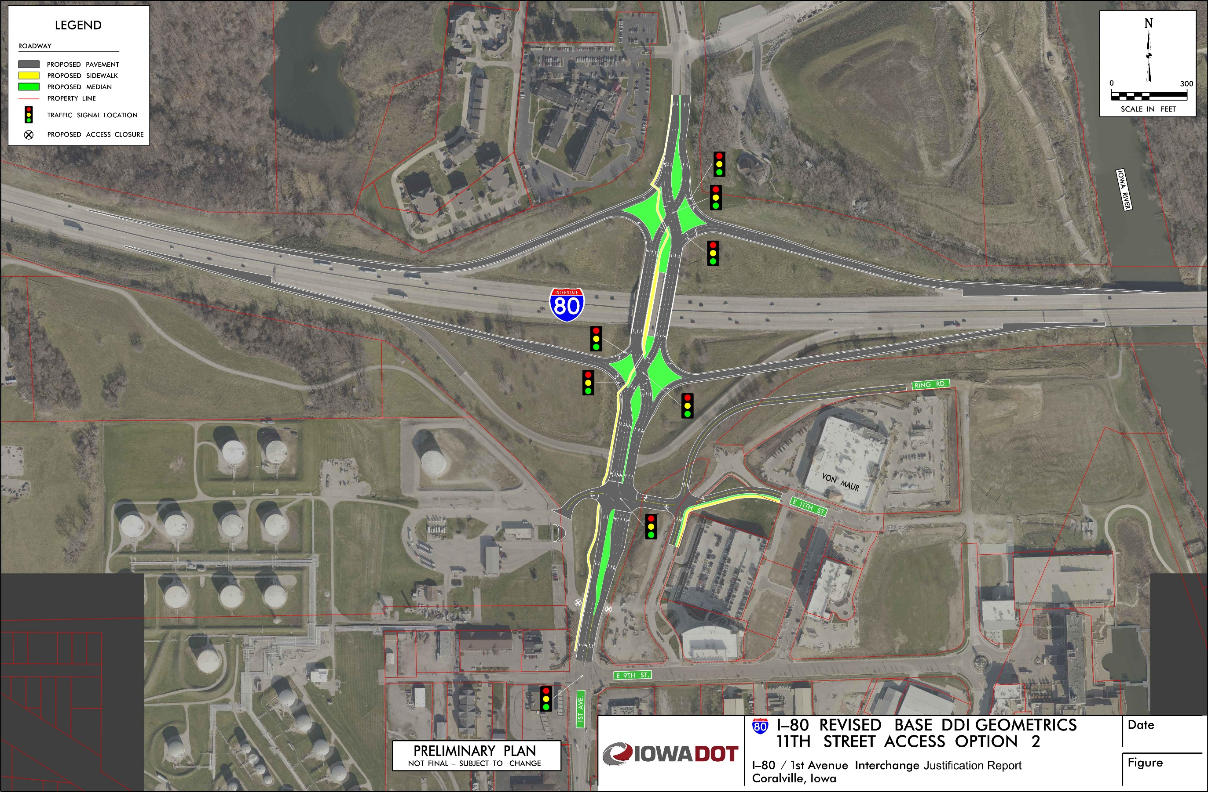
(Replace this example graphic with project conceptual layout graphic)

Alternatives Analysis
Analysis of Build alternatives was completed to determine the expected operations and safety for the proposed access change. Operational analysis was completed for state the Build scenarios that were analyzed. Predictive crash analysis was completed for state the Build scenario that were analyzed.

Design Year 20XX Build Conditions Traffic Forecasts
Design year Build conditions traffic forecasts.
For projects where the design year Build conditions traffic forecasts are the same as the design year No-Build conditions traffic forecasts, provide a statement similar to, “Design year 20XX Build conditions traffic forecasts are the same as those for the No-Build conditions.”, and provide any additional narrative to document why they are the same.
For projects where the design year Build conditions traffic forecasts are different from the design year No-Build conditions traffic forecasts, provide comparison of the Build conditions forecasts to No-Build conditions forecasts and existing volumes. The comparison of traffic forecasts should be provided via table(s) and narrative as appropriate. A sample table for comparing traffic forecasts is provided below.
Table 7-1. Daily Volume Comparison between Existing and Design Year Conditions
Location | Daily Traffic Volumes
 | Existing | Design Year 20XX No-Build | Design Year 20XX Build
Interstate mainline location 1 | XX,XXX | XX,XXX | XX,XXX
Interstate mainline location 2 | XX,XXX | XX,XXX | XX,XXX
Interstate mainline location 3 | XX,XXX | XX,XXX | XX,XXX
Interstate mainline location 4 | XX,XXX | XX,XXX | XX,XXX
Crossroad A north of Interstate | XX,XXX | XX,XXX | XX,XXX
Crossroad A south of Interstate | XX,XXX | XX,XXX | XX,XXX
Crossroad B north of Interstate | XX,XXX | XX,XXX | XX,XXX
Crossroad B south of Interstate | XX,XXX | XX,XXX | XX,XXX
Crossroad C north of Interstate | XX,XXX | XX,XXX | XX,XXX
Crossroad C south of Interstate | XX,XXX | XX,XXX | XX,XXX
Source: Source, Date.
For projects where the design year Build conditions traffic forecasts are different from the design year No-Build conditions traffic forecasts, provide a figure to illustrate design year Build conditions traffic forecasts within the area of influence (similar to those provided for the existing volumes and design year No-Build conditions forecasts). Provide additional details to describe the design year Build conditions traffic forecasts within the area of influence as appropriate. It may be necessary to provide multiple figures if multiple Build alternatives were evaluated. If design year Build conditions operational analysis results are displayed on a figure that also illustrates design year Build conditions traffic forecasts, it may be appropriate to move materials from this section into the Design Year Build Conditions Operational Analysis section (a separate figure for design year Build conditions traffic forecasts may then not be necessary). If design year Build conditions traffic forecasts details are provided in the Design Year Build Conditions Operational Analysis section, delete this section (including the section heading).

Design Year 20XX Build Conditions Operational Analysis
Operational analysis was performed for design year 20XX Build conditions for the periods (e.g., AM and PM peak hours) to determine the expected future operations within the area of influence with the proposed access change. The results for design year 20XX Build conditions operational analysis are shown in list tables and figures. Modify or duplicate the previous sentence to account for projects that include analysis with more than one tool and/or have multiple Build alternatives and specify the tool for each series of tables/figures.
Provide tables and/or figures to report results of the design year Build conditions operational analysis as appropriate. Formatting of these tables and figures should match those used to report results for the existing conditions and design year No-Build conditions. Provide a summary of the results in paragraphs or bullets to supplement tables and figures, highlighting the overall operations within the area of influence, and noting locations with poor operations or other operational concerns.

Design Year 20XX Build Conditions Predictive Crash Analysis
Design year 20XX predictive crash analysis was performed to determine the expected change to crashes within the area of influence resulting from the proposed access change. Predictive crash analysis was completed using state the method or tool used. The analysis was performed for state locations within the area of influence (e.g., Interstate mainline segments, ramps and ramp terminal intersections) within the area of influence.
Provide a summary of the expected change to crashes resulting from the proposed access change. It may be appropriate to provide tables and/or figures to illustrate these results. An example table for reporting the results of predictive crash analysis is provided below. Additional reporting examples are provided in the Iowa DOT Data Driven Safety Guidance document.
Table 7-2: Predictive Crash Alternative Comparison
Segment ID | Design Year 20XX Predicted Crashes¹
 | No Build |  | Build Alternative 1 |  | Build Alternative 2
 | Total Crashes | Crashes/100 MVM | Total Crashes | Crashes/100 MVM | Total Crashes | Crashes/100 MVM
Seg 1 | 10.4 | 88 | 10.1 | 70 | 10.5 | 68
Seg 2 | 9.3 | 67 | 9.2 | 53 | 9.8 | 50
Seg 3 | 9.1 | 66 | 8.8 | 51 | 8.8 | 51
Seg 4 | 8.5 | 70 | 11.2 | 74 | 11.2 | 74
Seg 5 | 2.9 | 62 | 2.6 | 54 | 3.2 | 50
Source: Tool, Agency or Company that conducted the analysis, Date
¹ Green highlighted cells indicate predicted crash frequency or rate for a Build alternative below the predicted frequency/rate for the No Build alternative. Pink highlighted cells indicate predicted crash frequency or rate for a Build alternative above the predicted frequency/rate for the No Build alternative.

Alternatives Evaluation Summary and Selection of Preferred Alternative
Alternatives evaluation summary and selection of preferred alternative.
Provide a summary of the design year Build conditions operations and safety analysis results. Provide any other evaluations completed, including comparison of costs, impacts, constructability, multi-modal accommodations, stakeholder/public support, etc. Identify a preferred alternative. If refined conceptual drawings are developed for the preferred alternative, it may be appropriate to provide an additional figure (or series of figures). If only one Build alternative was evaluated, update the section heading to “Alternative Evaluation Summary”.

Preferred Alternative Guide Sign Layout
Preferred alternative guide sign layout.
Provide a guide sign layout for the preferred alternative. An example guide sign layout is provided in the figure below.

Figure 7-1. Preferred Build Alternative Guide Sign Layout
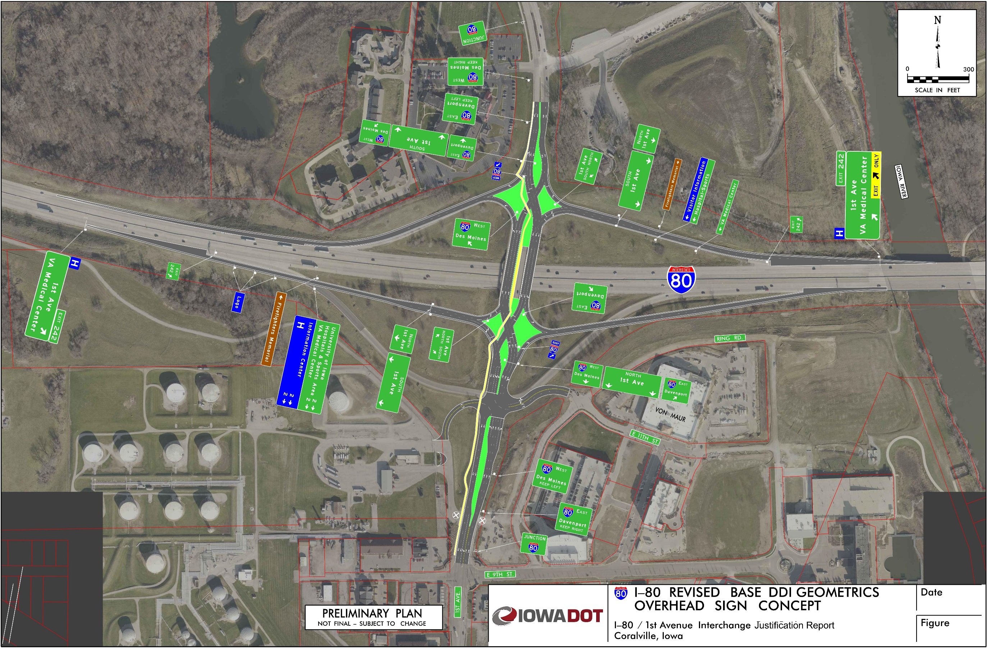
(Replace this example graphic with project conceptual layout graphic)

Opening Year 20XX Build Conditions Operational Analysis
The expected opening year for the proposed access change is year 20XX. Traffic forecasts developed for opening year conditions of the preferred Build alternative are provided in Figure 7-2.
Provide additional details to describe the opening year Build conditions traffic forecasts within the area of influence as appropriate. If opening year Build conditions operational analysis results are displayed on a figure that also illustrates opening year Build conditions traffic forecasts, it may be appropriate to mention that the forecasts are provided on a figure in conjunction with the opening year Build conditions operational analysis results.
Figure 7-2. Opening Year 20XX Build Conditions Traffic Forecasts
Insert graphic for opening year Build conditions traffic forecasts
Provide a figure to illustrate opening year Build conditions traffic forecasts within the area of influence (similar to forecast figures used for other scenarios). Delete this figure if opening year Build conditions traffic forecasts are provided on a figure in conjunction with the opening year Build conditions operational analysis results.
Operational analysis was performed for opening year 20XX Build conditions for the periods (e.g., AM and PM peak hours) to determine the expected operations within the area of influence during the first year of operations with the proposed access change. The results for opening year 20XX Build conditions operational analysis are shown in list tables and figures. Duplicate the previous sentence if more than one tool is used for the operational analysis and specify the tool for each series of tables/figures.
Provide tables and/or figures to report results of the opening year Build conditions operational analysis as appropriate. Formatting of these tables and figures should match those used to report operational results for other scenarios. Provide a summary of the results in paragraphs or bullets to supplement tables and figures, highlighting the overall operations within the area of influence, and noting locations with poor operations or other operational concerns.

Interim Year 20XX Build Conditions Operational Analysis
This section is only applicable for projects that include an interim year evaluation. Evaluation of conditions during an interim year is typically only required for a phased project, where the interchange is planned to operate for a period of time beyond the original phase’s opening year before additional phases of the project are constructed. For projects that do not include interim year evaluation, delete this section (including the section heading).
Describe interim year conditions.
Describe the improvements in the first phase(s) of the project that represent the interim conditions. Provide a timeline for phasing of improvements. Provide a figure showing interim year Build conditions traffic forecasts (this may be combined with an operational analysis results figure depending on the format used to display forecasts for other project scenarios).
Provide tables and/or figures to report results of the interim year Build conditions operational analysis as appropriate. Formatting of these tables and figures should match those used to report operational results for other scenarios. Provide a summary of the results in paragraphs or bullets to supplement tables and figures, highlighting the overall operations within the area of influence, and noting locations with poor operations or other operational concerns.
For projects where multiple interim years/phases were evaluated, provide description and evaluation for each interim year/phase.

Social, Economic and Environmental Reviews
This chapter is only applicable for projects where any of the following are not included in a NEPA or other approved planning study, such as a Location Study:
- Land use and transportation plan consistency with the proposed access change.
- Coordination for local system improvements to accommodate the proposed access change.
Depending on the project, some or all of the items listed above may not be included in a NEPA or other approved planning study, and need to be documented in the IJR. For projects where all of the items listed above are included in a NEPA or other approved planning study, delete this chapter (including subsections and the chapter heading).
Social, economic and environmental reviews were completed to document list the items from the instructional bullet list above that were completed for the IJR.

Land Use and Transportation Plan Consistency
This section is only applicable for projects where land use and transportation plan consistency with the proposed access change is not discussed in a NEPA or other approved planning study. For projects where this is discussed in a NEPA or other approved planning study, delete this section (including the section heading).
Land use and transportation plan consistency.
List the local and regional planning documents that include the proposed access change, including the Metropolitan Planning Organization (MPO) or Regional Planning Agency (RPA) Long Range Transportation Plan (LRTP), local planning agency Transportation Improvement Program (TIP), and Statewide Transportation Improvement Program (STIP). List any other planned improvements on the Interstate or crossroad within proposed access change and describe how the proposed change is consistent with those planned improvements.

Coordination for Local System Improvements
This section is only applicable for projects where coordination for local system improvements to accommodate the proposed access change is not discussed in a NEPA or other approved planning study. For projects where this is discussed in a NEPA or other approved planning study, delete this section (including the section heading).
Coordination for local system improvements.
Describe any local system improvements that are necessary to accommodate the proposed access change and ensure traffic can be delivered to and from the proposed access. Describe the coordination with public or private entities to identify fiscal responsibilities and gain commitment for constructing local improvements needed to accommodate the proposed access change.

Conclusions and Recommendations
The reviews and evaluations completed for this IJR are summarized below, including responses to the FHWA Policy on Access to the Interstate System requirements. A final recommendation for the proposed access change is provided based on the evaluations and conclusions documented in this IJR.

Conclusions
Provide a summary of results for traffic forecasts, operational analysis and safety analysis completed for existing, No-Build and Build conditions. Limit the discussion on analysis methodologies only to materials necessary to relate analysis results. This summary is typically on the order of one to three paragraphs. A sample summary of existing, No-Build and Build conditions is provided below.
Existing conditions operational analysis show that all study area freeway segments and intersections operate at LOS C or better. Analysis of recent historical crash data concludes that the crash rates for intersections A and B are among the top 200 highest in the state, and have had an average of XX injury crashes per year over the past five years.
Traffic volumes are expected to increase by 50% in the study area by design year 20XX. The design-year No-Build conditions are expected to experience operations at or over capacity during the AM and PM hours for the majority of freeway segments and intersections within the area of influence.
The improvements associated with the preferred Build alternative are expected to provide operations of LOS C or better operations within the area of influence for design year 20XX weekday peak period travel conditions. Additionally, the crash prediction analysis concluded that the preferred Build alternative is expected to yield a lower number of crashes for all crash severity than the No-Build condition.
The reviews and evaluations completed for this IJR are further summarized in the following section that reviews the FHWA Policy on Access to the Interstate System and provides responses to the FHWA Policy requirements.

FHWA Policy Review and Response
The FHWA Policy on Access to the Interstate System includes the requirements for the justification and documentation necessary to substantiate any access change request on the Interstate System that is submitted to the FHWA for approval. FHWA’s decision to approve a request is dependent upon the information developed in support of fulfilling the requirements identified in the Policy.
The current FHWA Policy on Access to the Interstate System (effective May 22, 2017) includes two requirements, which focus on safety, operational and engineering considerations of the access change request. FHWA Policy requirements and responses to those requirements based on the reviews and evaluations completed for this IJR are provided in the following sections.

Operations and Safety (2017 FHWA Policy Requirement 1)
An operational and safety analysis has concluded that the proposed change in access does not have a significant adverse impact on the safety and operation of the Interstate facility (which includes mainline lanes, existing, new, or revised ramps, and ramp intersections with crossroad) or on the local street network based on both the current and the planned future traffic projections. The analysis should, particularly in urbanized areas, include at least the first adjacent existing or proposed interchange on either side of the proposed change in access (Title 23, Code of Federal Regulations (CFR), paragraphs 625.2(a), 655.603(d) and 771.111(f)). The crossroads and the local street network, to at least the first major intersection on either side of the proposed change in access, should be included in this analysis to the extent necessary to fully evaluate the safety and operational impacts that the proposed change in access and other transportation improvements may have on the local street network (23 CFR 625.2(a) and 655.603(d)). Requests for a proposed change in access should include a description and assessment of the impacts and ability of the proposed changes to safely and efficiently collect, distribute, and accommodate traffic on the Interstate facility, ramps, intersection of ramps with crossroad, and local street network (23 CFR 625.2(a) and 655.603(d)). Each request should also include a conceptual plan of the type and location of the signs proposed to support each design alternative (23 U.S.C. 109(d) and 23 CFR 655.603(d)).
Sample response and guidance is provided below.
The traffic operational analyses conducted for the preferred Build alternative concluded that the proposed change in access would not have an adverse impact to operations of the Interstate System. The improvements associated with the preferred Build alternative are expected to provide operations of LOS C or better operations within the area of influence for design year 20XX weekday peak period travel conditions. Additionally, the crash prediction analysis concluded that the preferred Build alternative is expected to yield a lower number of crashes for all crash severity than the No-Build condition. A conceptual signing plan for the preferred Build alternative was completed to illustrate signing needs related to the preferred Build alternative. The criteria for the FHWA Policy Requirement 1 have been addressed through these operational and safety analyses.
- Provide a summary of the operational analyses for opening year and design year traffic demands with the proposed access change to demonstrate adequate traffic operations on the Interstate System.
- Provide a summary of the safety analysis to demonstrate the proposed access change will not have adverse impacts to safety on the Interstate System.
- Reference the completed conceptual signing plan for the Interstate System with the proposed access change.

Access Connections and Design (2017 FHWA Policy Requirement 2)
The proposed access connects to a public road only and will provide for all traffic movements. Less than "full interchanges" may be considered on a case-by-case basis for applications requiring special access, such as managed lanes (e.g., transit or high occupancy vehicle and high occupancy toll lanes) or park and ride lots. The proposed access will be designed to meet or exceed current standards (23 CFR 625.2(a), 625.4(a)(2), and 655.603(d)). In rare instances where all basic movements are not provided by the proposed design, the report should include a full-interchange option with a comparison of the operational and safety analyses to the partial-interchange option. The report should also include the mitigation proposed to compensate for the missing movements, including wayfinding signage, impacts on local intersections, mitigation of driver expectation leading to wrong-way movements on ramps, etc. The report should describe whether future provision of a full interchange is precluded by the proposed design.
Sample response and guidance is provided below.
The proposed access change will provide full access to and from each roadway (no restricted turning movements). All roadways that are part of the proposed reconfiguration are public roadways. The proposed geometric design of the interchange conforms to current Iowa DOT and AASHTO design standards and policies. The criteria for the FHWA Policy Requirement 2 have been addressed through the review of access and design standards.
- State if the proposed access change will provide full access to and from each roadway at the interchange (no restricted turning movements) and that the proposed Interstate access is to a public road.
  - If full access will not be provided, describe why full access will not be provided and summarize additional improvements needed to accommodate full access or mitigate the missing movements.
- State the design standards used for the proposed access change to demonstrate use of sufficient engineering for viability and constructability of the proposed access change.

Recommendations
Provide recommendations for the proposed access change based on the evaluations and conclusions documented in the IJR. A sample recommendation is provided below.
Based on the evaluations and conclusions documented in this IJR, it is recommended to modify the existing diamond interchange on I-80 at XX Street in XXXXX County, Iowa to a diverging diamond interchange, as illustrated in this report. It is recommended to construct the new southbound bridge over I-80 off alignment to minimize the impacts to traffic during construction. The interchange improvements should be closely coordinated with the local agency to ensure improvements needed at adjacent intersections, as identified and documented in this report, are constructed in coordination with the interchange improvements.

Appendix
List of appendix items.
Provide a list of items included in the appendix. It may be appropriate to include items in a digital appendix. Typical appendix items include:
- Design criteria worksheets
- Crash data
- Operational analysis output files
- M&A document

