The following describes how to process raw Hamburg data files using the Iowa DOT Hamburg spreadsheet.

1. Create a folder specifically for all of the files associated with the Hamburg test.
2. Place a copy of the most recent version of the Iowa DOT Hamburg Spreadsheet in the folder and rename to track the mix being tested. The most recent version of the Iowa DOT Hamburg Spreadsheet should always be used and can be found at <https://iowadot.gov/consultants-contractors/construction-materials/hot-mix-asphalt-hma>. The spreadsheet file is called Hamburg Version 2.XX.
3. Copy any other files associated with the Hamburg test to the folder. Before processing files may include the mix design, raw data file from Hamburg, gyratory lab voids, etc… After processing the Hamburg raw data a text file will be created and can be saved in the folder.
4. Once the folder and files are set up, open the Iowa DOT Hamburg Spreadsheet. A screen as follows should appear. This is the only sheet you will typically be using to process the raw Hamburg data.

1. Click on the Clear All button located in the upper right corner of the screen. Once pressed the sheet will process for a period of time and clear any old data. This may take a minute or two depending on the processing power of your computer. Once completed a screen as follows should appear. The sample type has been defaulted as field mix (Gyratory Specimens) if it is something different, use the pull down to change it.

1. Under the header, use the pull down to enter the county and then enter all remaining information by typing it in. The data file box field should be left blank as it will be filled in automatically when you save the processed file. Leave the box checked next to process unfiltered sensors.
2. Under the left wheel heading, type the information in the yellow shaded cells and then use the pull downs in the red cells to select the mix type and binder grade. The mix type must be entered for the sheet to work.
3. The information under the right wheel should currently be blank. If you did not run the right wheel leave it blank. If you ran a different mix under the right wheel then enter all of the information for that sample/mix. If the right wheel was run with the same mix as the left wheel, click the button same as left wheel off and then click it back on and your information should then be copied under the right wheel.
4. Leave sensor under the left and right wheel as average.
5. At this point, all of the project, mix, and equipment information is entered and you are ready to start the analysis.
6. Select start. A pop up as shown below should appear. Select run new test.

1. Another pop up as shown below should appear asking if you want to process all sensors. Select yes.

1. Another pop up as shown below will appear. Select ok. A file manager dialog box will appear allowing you to find and select the raw data file from the Hamburg tester.

1. Use the file manager dialog box to select the desired raw data file you want to analyze. As shown below we will be selecting the 56.xls file to analyze. Once selected select ok.

1. A dialog box will open up asking you to select the data to import. When both wheels are being used select both.

1. The sheet will now process the data. This will take several minutes and progress will be displayed in a pop up as shown below.

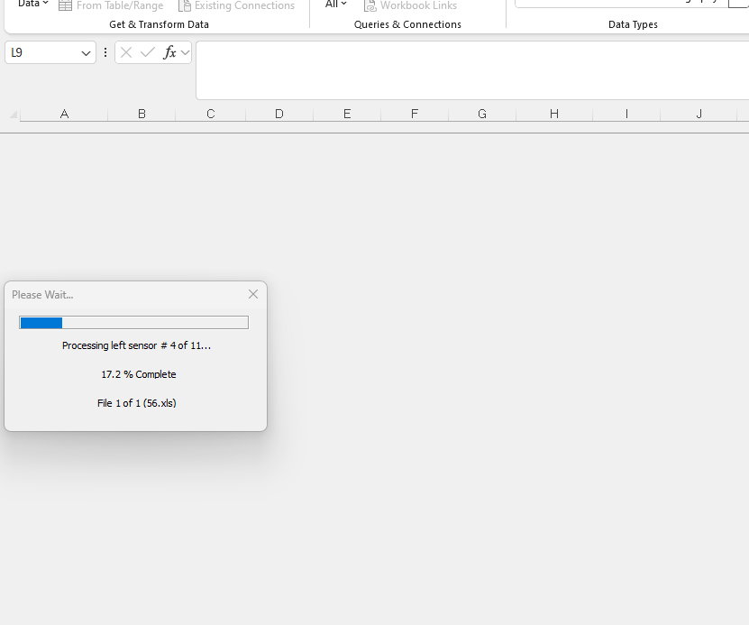

1. Once complete a dialog box as shown below will appear. Click ok. The data should populate the spreadsheet and then a file manager dialog box should appear.

1. Select the location you want the txt file saved at and click save. The analysis is now complete.

1. The data can now be reviewed. A summary of the data is provided below the plots. The specification limit is indicated to the right of the data and a pass or fail is indicated towards the bottom of the page. The file can now be saved and then closed.

