**IOWA DEPARTMENT OF TRANSPORTATION**

**TO OFFICE:** District # **DATE: {**Date}

**ATTENTION:** District Engineer **REF.:** {County} County

{Phase #}

**FROM:** Field Exam Engineer or DPE or Consultant Project Code: {Pin}

**OFFICE:** Design

**SUBJECT:** Field Exam Review (D02)

A field exam was held on {D02 field exam date} to review the proposed plan for {Work Code} of the {Phase Location} {Bridge / Culvert / Roadway} over {Road or Stream}.

Those present included the following: {Attendance}

This project involves…. {From D00 Concept Statement}

{Mainline} is a service level “{S_level}” roadway. The {Program Year} ADT is estimated to be {Program Year VPD} VPD with {Program Year Trucks}% trucks. The {Design Year} ADT is estimated to {Design Year VPD} VPD with {Design Year Trucks}% trucks.

The field exam plans were developed based on the concept. The proposed project will involve {Work Code} of the Existing {Existing Description} with a {New Description} utilizing {Staging / offsite detour}. The project {May or will not} involve changing the vertical or horizontal alignments. {This will require a minimum grade raise of {Grade Raise} to meet clearance requirements over {Road or Stream} and thus requires approximately {Mainline change} of roadway reconstruction.}

{Special existing conditions}

{NEPA section}

The typical section adjacent to the {Bridge approaches / Culvert / Roadway} will be {Pavement width} wide pavement with {Shoulder width} {Shoulder type} and consist of {Mainline type}. {District typical preferences}

{Design Bureau notes}

{District Notes}

{Location Environment Bureau}

{Special Notes / existing equipment notes}

{Traffic critical project notes}

Plan sheets may be viewed at:

{*Add ProjectWise Link*}

This project is currently scheduled for a {Letting Month Year} letting. The estimated cost of construction shown in the project concept was **$ 0,000,000**.

**Field Exam letter, electronic submittal, sent by the Field Exam Engineer or Section Engineer.**

**You can use the sample email below to paste the text and cc list into your email.**

Hello,

The link below contains the D2 letter for

County : {County} *Directly from Masterworks

Project Code : {Phase #} *Directly from Masterworks

Phase Number : {Phase #} *Directly from Masterworks

Location : {Phase Location} *Directly from Masterworks

Work Code : {Work Code} *Directly from Masterworks

Project Directory : {*Add ProjectWise Link*} *Directly from Masterworks

{Masterworks project link}

{ProjectWise Document Link}

Thank you,

{Sender signature}

**District Engineers:**

District 1 - Smyth, Allison;

District 2 - Humpal, Nickolas;

District 3 - Felix, Jessica;

District 4 - Schram, Scott;

District 5 - Younie, Robert;

District 6 - Schnoebelen, James;

**Cc:** Nicholson, Kent; Jia, Yanxiao; Brakke, Chris; Nelson, James; Nop, Michael; Ellis, Jimmy; Majors, Shawn; Swenson, Mark; Stokes, Daniel; Hofer, Bradley; Sorenson, Willy; Wright, Eric; Brink, Kenneth; Poole, Christopher; Laaser-webb, Jan; Anderson, Stuart; Sprengeler, Daniel; Cuva, Nicole; Holst, Jason; Bartholomew, John; Dell, Mark; Harris, Rachel; Pohlen, Nathaniel; Breitbach, Donna; Smith, Brian; Van Dyke, Mark; Heeren, Douglas; Cagle, Gregory; Blue, Dana; Cook, Sarah; Hucker, Benjamin; Worrel, Brian; Narigon, Linda; Buss, Ashley; Add DPE’s or Field Exam Engineer

**Design Project Engineers:**

Schrock, Kyle; Flattery, Paul; Miller, Ryan;

**District 1:**

Vortherms, Jeremey; Hoskins, Jennifer; Skogerboe, Dustin; Leong, Frank; Adey, Benjamin; Passick, Sean; Nixon, Scott; Quam, Tami

*Location and Environment (Cultural, T&E, Water):*

Becker, Janee; Garton, Jill;

Asberry, Claire; Boone, Greene

{Location and Environment Bureau}; Polk, Story, Webster

Beavers, Brandy; Jasper, Poweshiek

Sloppy, Mark; Marshall, Tama

Walls, Brandon; Grundy, Hamilton, Hardin

*NEPA contacts:*

Newell, Deeann; Walter, Blake;

**District 2:**

Kelly, Mary; Thede, Barry; Ruter, Jason; Loecher, Ron; Olsen, Andrew; Kubik, Tyler; Erickson, Daryl; Gelhaus, Roy; Quam, Tami

Siems, Kim; *Bridge Projects*

*Location and Environment (Cultural, T&E, Water):*

Bacon, Jeffrey; Struecker, Brock; Walls, Brandon;

*NEPA contacts:*

Newell, Deeann; Walter, Blake;

**District 3:**

Tymkowicz, Shane; Huju, Todd; Pryor, Dylan; Pottorff, Justin; Thayer, Michael; Klemme, Jason; Quam, Tami

Sadler, Mark *(Maintenance and 3R Projects)*

*Location and Environment (Cultural, T&E, Water):*

Becker, Janee; Duncan, Chelsea; {Location and Environment Bureau}; Sturtz, Samuel;

*NEPA contacts:*

Newell, Deeann; Schwienebart, Christine;

**District 4:**

Mayberry, Wes; Dorsett, David; Epperson, Nathaniel; Redmond, Daniel; Sallach, Jason*(Maintenance Projects)*; Keller, Jennifer

Lechnowsky, Orest; Kohl, Jason; Harrison, Pottawattamie, Mills, Fremont, Page, Montgomery, & Shelby

Malone, Travis; Mocha, Nicholas; Audubon, Cass, Adams, Taylor, Guthrie, Adair, Union, Ringgold, Dallas, & Madison

*Location and Environment (Cultural, T&E, Water):*

Woodcock, Jacob; Duncan, Chelsea; Asberry, Claire;

*NEPA contacts:*

Newell, Deeann; Schwienebart, Christine;

**District 5:**

McElmeel, Steven; Finarty, Elizabeth; Archer, Bryan; Bielser, Darrick; Claeys, Mark; Keller, Jennifer

*Location and Environment (Cultural, T&E, Water):*

Woodcock, Jacob; Garton, Jill; Beavers, Brandy;

*NEPA contacts:*

Newell, Deeann; Leanos, Pedro;

**District 6:**

Tibodeau, Jesse; Abu Afifeh, Ahmad; Holak, Hugh; Lamping, John; Simonson, Adrian; Morrell, George; Alvarez, Danielle; Keller, Jennifer

*Location and Environment (Cultural, T&E, Water):*

Bacon, Jeffrey; Struecker, Brock; Sloppy, Mark;

*NEPA contacts:*

Newell, Deeann; Schwake, Christine;

Local FHWA: Program.Delivery-IA@fhwa.dot.gov. FHWA will be added on interstate inlay/reconstruction projects.

Railroad impacts: Woods, Amanda; Phillips, David

Others who attended the field exam.

**For Major Projects with a P03 Event**

Poole, Angela;

**District TSMO Engineers:**

Swisher, Andy; District 1, District 2 (except Blackhawk Co.), and I-35 in District 5

Yates, Austin; District 3 and District 4

Stone, Eryn; District 6, District 5 (except I-35), and Blackhawk Co. (District 2) 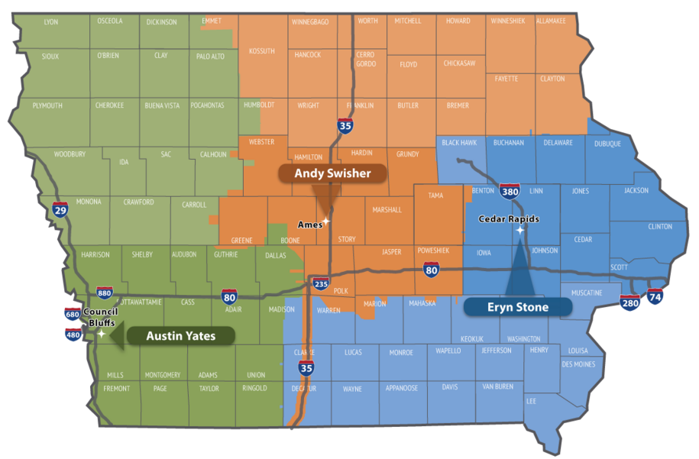

**Contact revision request:**

Email [DOT-Shell-Support](mailto:DOT-Shell-Support@iowadot.us?subject=D2%20Shell%20Letter%20Contact%20revision%20request)

Subject: D2 Shell Letter Contact revision request

Copy and Paste into body of email

Please change the Shell Letter Contact *[Contacts name and email]*.

They were in this position *[Title ; position ; District ; Bureau].*

They reported to *[Contacts name and email].*

*[Contacts name and email]* is the New *[Title ; position ; District ; Bureau]*.

This change needs to be done on *[ALL Shell Letters; Indicate Shell Letter(s) if different then email subject].*

Thank you

**Revision request:**

Email [DOT-Shell-Support](mailto:DOT-Shell-Support@iowadot.us?subject=D2%20Shell%20Letter%20revision%20request)

Subject: D2 Shell Letter revision request

Copy and Paste into body of email

Please find the attached Markup with the requested change. [Screen image of change, or marked up document]

This change needs to be done on *[ALL Shell Letters; Indicate Shell Letter(s) if different then email subject].*

Thank you