**Subject:** Primary County, Phase Number - D4 Submittal

**D4 - Design Plans for Bridge Submittal:**

Primary County:

Project Code:

Phase Number:

Phase Location:

Work Code:

Project Directory Number:

**ADE/DCE/RCE:**

Please provide the following information to the **Design Team** within 2 weeks of this submittal**:**

**Yes No**

Field Lab

Field Office  

Materials to be salvaged on Tab. 110-13

If yes, select below and fill out contact name, phone# and salvage address:

Guardrail

Other. Please specify the items:

Contact name and phone#:

Address:

Traffic Control/Work Hour Restrictions

If yes, explain:

Special Events/Work Hours Restrictions

If yes, explain:

Project with detour:

If yes, who is responsible for furnishing, installing, maintaining and removing the detour:

Contractor

District will provide detour sheets.

DOT

Projects to be coordinated on Tab. 111-1

If yes, please provide project number(s) and type of work.

**D4 Submittal Folder:** Place_Link_Here

**Roadway Cost Estimate:** Place_Link_Here (Note: file should be named as Contract_ID_Design_Estimate.pdf)

Electronic files from Road Design will be submitted to the Contracts Bureau within 4 weeks of the B3 Submittal.

**Toggle ‘Yes or No’ if you have a PPP.**

*(For projects with over 50,000 CY of Contractor Furnished material (Embankment and/or Select material) include the following note with the email. In addition, see Design Manual 5B-3 for instructions on submitting plan sheets for review prior to final plan turn in.)*

***Place a copy of the DM5 plan set in the following location:***

This project requires over 50,000 CY of Contractor Furnished material. Plan sheets will be posted on the DOT website for review.

If you have any questions, feel free to email me.

**To: Bridge DPE**

{Final Design unit 1 leader}; Evans, David; Schroder, Steven;

District ADE/DCE/RCE: See names below and select appropriate RCE

**CC:**

Nelson, James S; Nop, Michael; Nicholson, Kent; Harris, Rachel; Pohlen, Nathan; Dell, Mark; Bradley, Bryan; Smith, Brian; Ta, Dung; Cagle, Gregory; Blue, Dana; Cook, Sarah; Brink, Kenneth; Poole, Angela;

**District 1**

ADE/DCE: Vortherms, Jeremey;Nixon, Scott;

RCE: Leong, Frank; Hoskins, Jenny; Skogerboe, Dustin;

Smyth, Allison;

**District 2**

ADE/DCE: Kelly, Mary; Gelhaus, Roy;

RCE: Loecher, Ron; Olsen, Andrew

Siems, Kim;

**District 3**

ADE/DCE: Tymkowicz, Shane; Klemme, Jason;

RCE: {Resident Construction Engineer}; {Resident Construction Engineer};

Todd, Frank;

**District 4**

ADE/DCE: Mayberry, Wes; Redmond, Daniel;

RCE: Dorsett, David;

**District 5**

ADE/DCE: McElmeel, Steven; Bielser, Darrick;

RCE: Finarty, Liz; Vanbuskirk, Christy

**District 6**

ADE/DCE: Tibodeau, Jesse; Alvarez, Danielle;

RCE: Holak, Hugh; Lamping, John; Simonson, Adrian;

**Projects on new alignment or adding lanes to create a multilane facility:**

* If major alignment changes are made at any point (such as bypasses, new interchanges, or significant changes, not just a 4-foot adjustment, etc.), please summarize the changes and send a link for the updated design files to the emails below.

Mauer, Paul; Clement, Jodi

**For Projects that require over 50,000 CY of Contractor Furnished material:**

DOT-Shell-Support@iowadot.us

**District TSMO Engineers:**

Swisher, Andy; District 1, District 2 (except Blackhawk Co.), and I-35 in District 5

Yates, Austin; District 3 and District 4

Abuissa, Newman; District 6, District 5 (except I-35), and Blackhawk Co. (District 2)

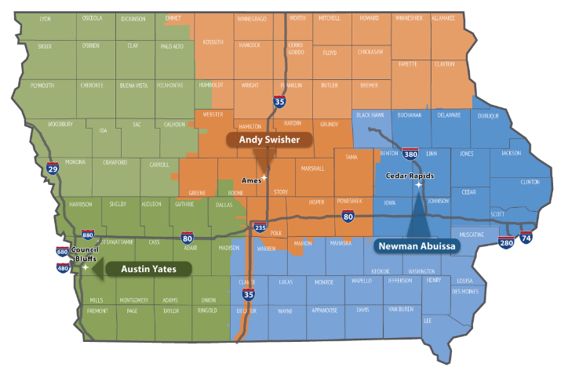

**Contact revision request:**

Email, [DOT-Shell-Support](mailto:DOT-Shell-Support@iowadot.us?subject=D4%20Shell%20Letter%20Contact%20revision%20request%20)

Subject: D4 Shell Letter Contact revision request

Copy and Paste into body of email

Please change the Shell Letter Contact *[Contacts name and email]*.

They were in this position *[Title ; position ; District ; Bureau].*

They reported to *[Contacts name and email].*

*[Contacts name and email]* is the New *[Title ; position ; District ; Bureau]*.

This change needs to be done on *[ALL Shell Letters; Indicate Shell Letter(s) if different then email subject].*

Thank you

**Revision request:**

Email [DOT-Shell-Support](mailto:DOT-Shell-Support@iowadot.us?subject=D4%20Shell%20Letter%20revision%20request%20)

Subject: D4 Shell Letter revision request

Copy and Paste into body of email

Please find the attached Markup with the requested change. [Screen image of change, or marked up document]

This change needs to be done on *[ALL Shell Letters; Indicate Shell Letter(s) if different then email subject].*

Thank you