**Subject:** Primary County, Phase Number - D6-9 Submittal, Bid Letting date: (XXXXX)

**D6-9 - Final Plan Submittal:**

Primary County:

Project Code:

Phase Number:

Phase Location:

Work Code:

Project Directory Number:

Plans to Methods Date: (XXXXX)

Note any projects that this project will be tied to.

PDFs of the final plans have been placed in the Contracts Plan Turn-in folders.

PDFs of the project estimate have been placed in the folder of W:\Highway\Contracts\Cost Estimates*Letting date yymmdd.* (Example: 191217 for Dec. 17, 2019 letting. Note: file should be named as Contract ID_Design_Estimate.pdf)

**D6-9 Submittal Folder:** Place_Link_Here

If you have any questions or comments, feel free to email me.

**To:**  Dunn, Mark; Thiel, Michael;

**Cc:**

Nicholson, Kent; Brakke, Chris; {Assistant Design Director}; Nelson, James S; Nop, Michael; Musgrove, Wes; Poole, Chris; Hofer, Brad; Stokes, Danny; Swenson, Mark A; Johnson, Katherine; Cagle, Gregory; Blue, Dana; Cook, Sarah; Kasper, Edward;{Contracts and Specifications Bureau}; Poole, Angela; Ryan, Stacy; Beddow, Alan; Harris, Rachel; Brink, Kenneth; Bradley, Bryan; Smith, Brian; Van Dyke, Mark; Merryman, Kevin; Ta, Dung; Worrel, Brian; Gansen, Elijah; Zeimen, Danny; Wilkinson, Cedric; Serio, Melissa; Johnson, Brian

**District 1:**

Smyth, Allison; Vortherms, Jeremey; Nixon, Scott; Passick, Sean; Adey, Ben; Breitbach, Donna;

*Location and Environment (Cultural, T&E, Water):*

Becker, Janee; Garton, Jill;

Asberry, Claire; Boone, Greene

Carlson, Michael; Polk, Story, Webster

Beavers, Brandy; Jasper, Poweshiek

Sloppy, Mark; Marshall, Tama

Walls, Brandon; Grundy, Hamilton, Hardin

**District 2:**

Humpal, Nickolas; Kelly, Mary; Erickson, Daryl; Gelhaus, Roy; Ruter, Jason; Loecher, Ron; Olsen, Andrew; Kubik, Tyler;

Siems, Kim; *Bridge Projects*

*Location and Environment (Cultural, T&E, Water):*

Bacon, Jeff; Struecker, Brock; Walls, Brandon;

**District 3:**

Felix, Jessica; Tymkowicz, Shane; {RCE}; {RCE}; Thayer, Michael; Klemme, Jason; Huju, Todd; Justin Pottorff; Pryor, Dylan;

*Location and Environment (Cultural, T&E, Water):*

Becker, Janee; Duncan, Chelsea; Carlson, Michael; Sturtz, Samuel

**District 4:**

Schram, Scott; Mayberry, Wes; Yates, Austin; Redmond, Daniel;

Lechnowsky, Orest; Kohl, Jason; Harrison, Pottawattamie, Mills, Fremont, Page, Montgomery, & Shelby

Malone, Travis; Mocha, Nicholas; Audubon, Cass, Adams, Taylor, Guthrie, Adair, Union, Ringgold, Dallas, & Madison

*Location and Environment (Cultural, T&E, Water):*

Woodcock, Jacob; Duncan, Chelsea; Asberry, Claire;

**District 5:**

Younie, Bob; McElmeel, Steven; Bielser, Darrick; Claeys, Mark;

*Location and Environment (Cultural, T&E, Water):*

Woodcock, Jacob; Garton, Jill; Beavers, Brandy;

**District 6:**

Schnoebelen, Jim; Tibodeau, Jesse; Alvarez, Danielle;

*Location and Environment (Cultural, T&E, Water):*

Bacon, Jeff; Struecker, Brock; Sloppy, Mark;

**Contract’s turn-in with NO DM5 Submittal:**

Serio, Melissa; Sprengeler, Dan;

**Railroad impacts:**

Woods, Amanda; Phillips, David

**ER projects:**

Hochberger, Ashley; Hucker, Benjamin;

**For Interstate Projects:**

Program.Delivery-IA@dot.gov

**For Projects that require over 50,000 CY of Contractor Furnished material:**

DOT-Shell-Support@iowadot.us

**District TSMO Engineers:**

Swisher, Andy; District 1, District 2 (except Blackhawk Co.), and I-35 in District 5

Yates, Austin; District 3 and District 4

Abuissa, Newman; District 6, District 5 (except I-35), and Blackhawk Co. (District 2)

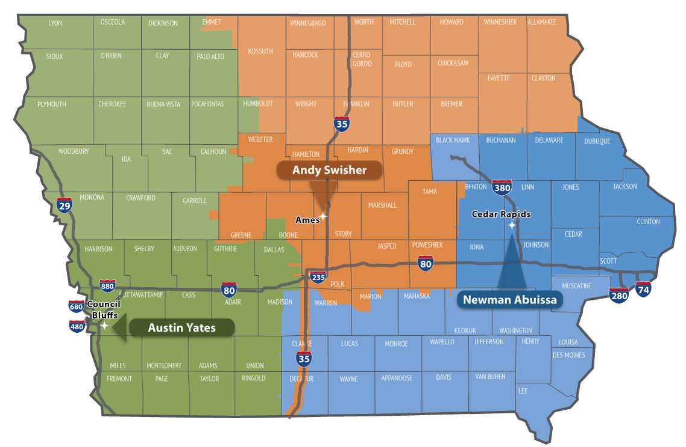

**Contact revision request:**

Email, [DOT-Shell-Support](mailto:DOT-Shell-Support@iowadot.us?subject=D3%20Shell%20Letter%20Contact%20revision%20request)

Subject: D3 Shell Letter Contact revision request

Copy and Paste into body of email

Please change the Shell Letter Contact *[Contacts name and email]*.

They were in this position *[Title ; position ; District ; Bureau].*

They reported to *[Contacts name and email].*

*[Contacts name and email]* is the New *[Title ; position ; District ; Bureau]*.

This change needs to be done on *[ALL Shell Letters; Indicate Shell Letter(s) if different then email subject].*

Thank you

**Revision request:**

Email, [DOT-Shell-Support](mailto:DOT-Shell-Support@iowadot.us?subject=D3%20Shell%20Letter%20revision%20request)

Subject: D3 Shell Letter revision request

Copy and Paste into body of email

Please find the attached Markup with the requested change. [Screen image of change, or marked up document]

This change needs to be done on *[ALL Shell Letters; Indicate Shell Letter(s) if different then email subject].*

Thank you