When beginning the Planning Environmental Linkages (PEL)/NEPA process, early agency coordination is necessary to involve local, state, and federal agencies who may have regulatory authority, jurisdiction, or interest in the proposed comments. Agencies can be invited using an agency coordination packet or scoping letter. Send FHWA a copy of the agency coordination packet or scoping letter where these requests occur as well as responses to the requests. Below are a list of potential cooperating and participating agencies.

Cooperating Agencies:
Cooperating agencies are defined as any state or federal agency that has jurisdiction by law or special expertise on any environmental impact involved in the proposed project. Below is a list of the typical cooperating agencies. Depending on the impacts of the proposed projects, additional agency(s) may be invited as a cooperating agency. If a project occurs with a border state, the appropriate region or district of the agency should be invited.

- US Environmental Protection Agency (EPA) – National Environmental Policy Act Team - Region VII
- US Department of Interior (DOI) – US Fish and Wildlife Service (Rock Island and/or Grand Island)
- US DOI – National Park Service (NPS) – when NPS lands are involved
- US DOI – Regional Office – Denver – when Section 4(f) properties are involved
- US Army Corps of Engineers (Rock Island District, Omaha District, and/or NE Iowa District)
- US Coast Guard – when on navigable streams or an EIS is being prepared

Participating Agencies:
Participating agencies are defined as local, state, or federal agencies that have an interest in the project. This role has less authority than a Cooperating agency but may be kept informed of project undertakings and asked to provide comment. Below is a list of potential local, state, or federal participating agencies. Based on the proposed impacts, any of these agencies may be invited to become cooperating agencies.

State / Federal Agency Coordination List:
- NRCS – State conservationist
- US Department of Housing and Urban Development (HUD) – include as necessary in urban areas
- Federal Emergency Management Agency (FEMA) – when floodplains are involved
- Federal Aviation Agency (FAA) – when near airports
- Federal Transit Administration (FTA)
- Federal Railroad Administration (FRA) – when railroad (RR) is involved
- State Historical Society of Iowa– IA DOT Cultural staff will distribute the letter
- Iowa Department of Natural Resources (DNR) – Environmental Services Division
- Iowa DNR – Conservation and Recreation Division
- Iowa DNR – Land and Water Conservation Fund Program – when Section 6(f) is involved

Other local agencies as necessary:
- County Conservation Board
- County Board of Supervisors
- Historical Societies
- City Planning Department
- County Planning Department
- County Engineer
- Public Works Director or City Engineer
- Mayor, City Council, or City Manager
- Local Iowa DNR (see map below)
- Local NRCS Conservationist; USDA Form 1006
- Iowa Soil and Water Conservation Districts – if Ag land present
- Iowa Department of Agriculture and Land Stewardship (IDALs) – if Ag land present
- Chamber of Commerce
- Parks and Recreation Department
- DOT/FHWA
- Utility Coordinator, Iowa DOT – Right of Way Bureau
- Cultural Resource Section for Tribal notification
- NEPA Document Manager copy of EC packet and distribution list
- FHWA NEPA – copy of EC packet and distribution list cc as FYI only

Additional Contact Information

Local DNR Wildlife Biologist

Retrieved: 2/6/2026
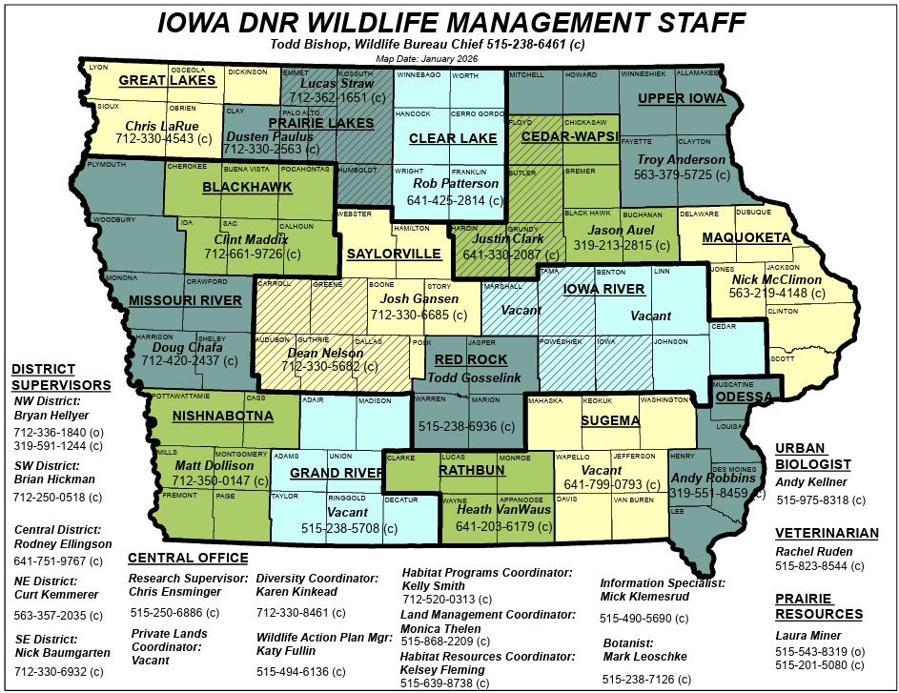

County Conservation Board (CCB) – find the appropriate CCB address at the following websites mycountyparks.org and County Parks

