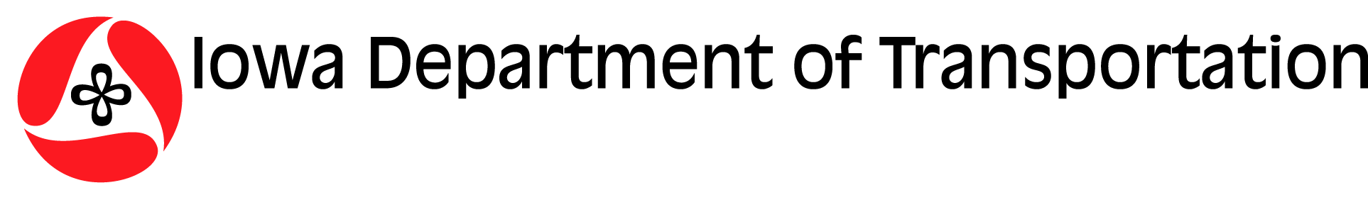 Determination of Effect for Threatened & Endangered Species
Form 760004 (08-13)
Project Name: |  |  |  |  | Highway No.: |  |  | County:
Project No.: | Letting Date: | PLSS/UTM: |  |  | Station No.:
Project Description:

Are there documented occurrences of T&E species within 1 mile of the project? Yes No
If yes, list species:

Are there documented occurrences of T&E species within the limits of construction? Yes No
If yes, list species:

Is there likely to be habitat for T&E species within the project’s limits of construction? Yes No
If yes, list species:

Describe current geographic setting (native habitats, adjacent land use, etc.) and potential project impacts:

Will the project likely require borrow? Yes No
DETERMINATION OF EFFECT - ACTION
No Effect No Effect (by following recommendations) Needs Further Study
May Affect – Not Likely to Adversely Affect May Affect – Likely to Adversely Affect
Further Study – Consisting of the Following |  |  | Iowa DOT Recommendations
References:
Natural Areas Inventory T&E Species Range Maps Aerial Photos Soils of Concern Data
Other:
Prepared by: |  |  |  |  |  |  | Date:
Agency Concurrence: |  |  |  |  |  |  | Date:
INDIVIDUAL SPECIES EVALUATION - Determination of Effect for Threatened & Endangered Species (Continued)
Project Name: |  |  |  | Highway No.: |  | County:
Project No.: | Letting Date: | PLSS/UTM: |  | Station No.:
SPECIES EVALUATION
Species of Concern: Federal State |  |  | Species Trait or Characteristic:
Description of Project Impacts:

Direct Effects from habitat/species impacts: Take Harm Harass
Effects beneficial, insignificant, and/or discountable Effects possible but can be managed Effects are major
Indirect Effects from habitat/species impacts: Harm Harass
Effects beneficial, insignificant, and/or discountable Effects possible but can be managed Effects are major
Cumulative Effects from habitat/species impacts: Harm Harass
Effects beneficial, insignificant, and/or discountable Effects possible but can be managed Effects are major
NOTES:

SPECIES SPECIFIC DETERMINATION OF EFFECT
May Affect – Not Likely to Adversely Affect May Affect – Likely to Adversely Affect
Prepared by: |  |  |  |  | Date:
Agency Concurrence: |  |  |  |  | Date:

