
Iowa Airport Land Use Guidebook

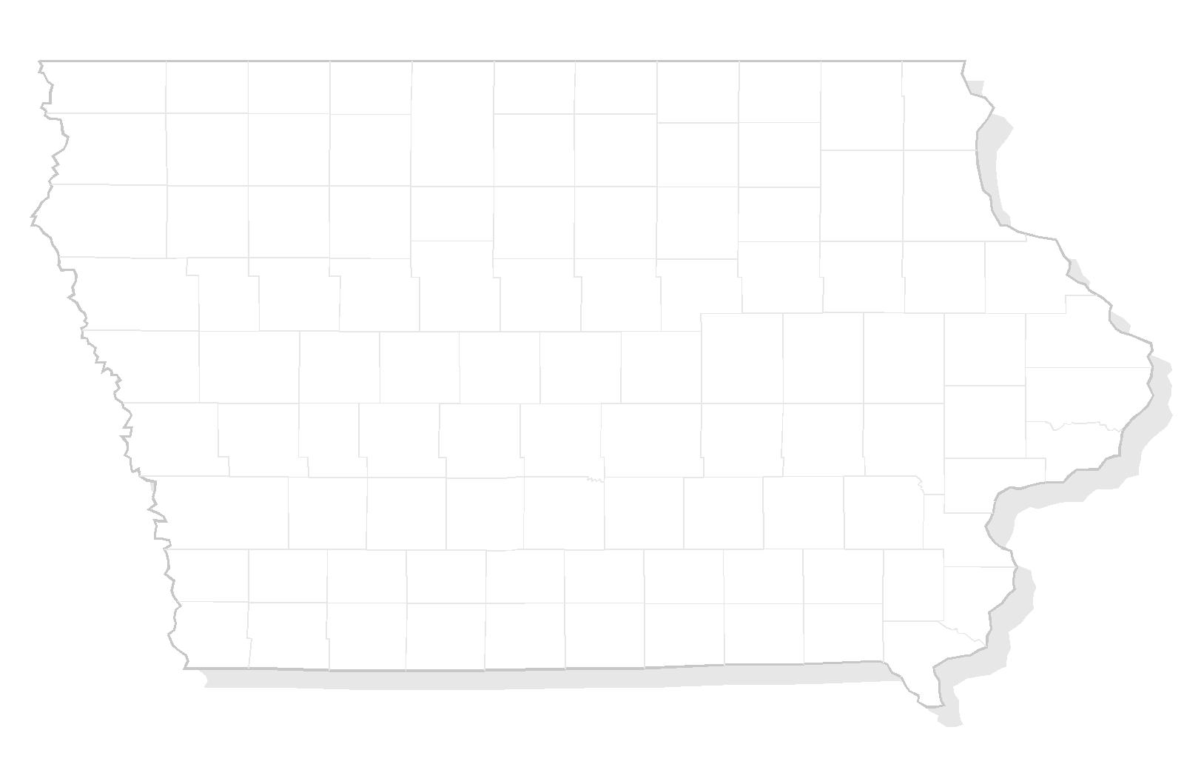

APPENDIX F
NOISE EASEMENT

THIS PAGE INTENTIONALLY LEFT BLANK

Sample – Noise Easement

This indenture made this _____ day of ____________________, 20____, by ____________________ and between __________________________, hereinafter referred to as Grantor, and ________________ County, a municipal corporation organized and existing under the laws of the State of Iowa, hereinafter referred to as Grantee, witnesseth:

WHEREAS the Grantor is the owner in fee of a certain parcel of land in the County of _________________, State of Iowa; and

WHEREAS said parcel of land is near ________________________________ Airport, and is within an Airport Noise Overlay Zone as defined by the Zoning Ordinance of the County of _________________, and is subject to existing or forecast aircraft noise levels in excess of 65 DNL; and

WHEREAS the Grantee is the owner and operator of the ____________________________Airport; and

WHEREAS the Grantor proposes to make a use of said land and to develop thereon the following:

_____________________________________________________________

_____________________________________________________________

which use and development require approval by Municipal and County authorities subject to the applicable provisions of law; and

WHEREAS the Grantor has been advised that the subject property is located in a noise-impacted area; that these present and future noise impacts might be annoying to users of the land for its stated purpose and might interfere with the unrestricted use and enjoyment of the property in its intended use; that these noise impacts might change over time by virtue of greater numbers of aircraft, louder aircraft, seasonal variations, and time-of-day variations; that changes in airport, air traffic control operating procedures or in airport layout could result in increased noise impact; and that the Grantor’s and users’ own personal perceptions of the noise exposure could change and that his or her sensitivity to aircraft noise could increase;

NOW, THEREFORE, for and in consideration of the mutual covenants, agreements and conditions contained herein, the parties hereto agree as follows:

Grantor does hereby grant a permanent noise easement to Grantee overall of the following described real estate:

Provided, however, that the airspace in which the said easement and right-of-way is herein granted shall be that airspace which lies at or above ___________ feet above mean sea level (MSL) which is __________ feet above the present surface level of the land, which land is __________ feet above MSL. Determination of non-conforming obstructions shall be based on the height of the obstruction above mean sea level (MSL).

By virtue of this agreement, the Grantor, for and on behalf of himself and all successors in interest to any and all of the real property above described, waives as to Grantee or any successor agency legally authorized to operate said airport, any and all claims for damage of any kind whatsoever incurred as a result of aircraft using the “easement” granted herein regardless of any future changes in volume or character of aircraft overflights, or changes in airport design and operating policies, or changes in air traffic control procedures.

The Noise Easement shall run with the land of the Grantor, as hereinabove described, for the benefit of the Grantee, and its successors and assigns in the ownership, use and operation of the aforesaid airport.

Grantee, its successors and assigns, shall have and hold said easement and all rights appertaining thereto until said airport shall be abandoned and shall cease to be used for airport purposes.

IN WITNESS WHEREOF, the Grantor has hereunto set its hand and seal the day and year first above written.

____________________________________ (SEAL)

____________________________________ (SEAL)

NOTARY ACKNOWLEDGEMENT

STATE OF IOWA

COUNTY OF ________________________

Personally, came before me, this _________ day of _____________, 20____.
_______________________ and _______________________________ of the above named Corporation, to me known to be the person who executed for foregoing instrument and to me known to be such __________________________ and ______________________________ of said Corporation, and acknowledged that they executed the foregoing instrument such officers as the deed of said Corporation, by its authority.

__________________________________________
Notary Public, State of Iowa

My Commission Expires ______________________

THIS PAGE INTENTIONALLY LEFT BLANK

