## Please contact [mvd.learninganddevelopment@iowadot.us](mailto:mvd.learninganddevelopment@iowadot.us) for assistance with using these Any County media postings.

**Text Option**

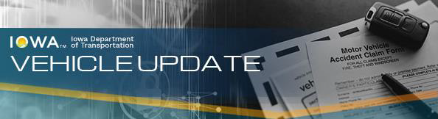

Effective January 1, 2025, a customer can apply to any county treasurer for the following title and registration-related transactions:

* Regular title and registration
* Interstate motor carrier title (Prorate title)
* Title and registration for specially constructed vehicle
* Replacement title
* Dealer titles
* Security Interest
* Junking certificates
* Salvage titles
* Rebuilt
* Delinquent Dealer Title
* In-transit title
* Non-transferable registration
* Title after Non-transferable registration
* In-transit plates
* 30-day permit

Additionally, the fees for many titling and registration transactions will increase ($10-$30, depending on the circumstances), with the additional fee amount being retained by the county performing the transaction.

For questions, please contact your county treasurer’s office.

**Picture Option**

