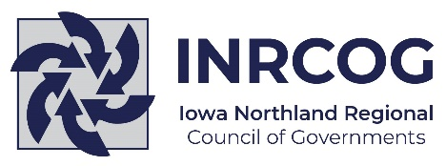
PARTNERS FOR PROGRESS
Developing Strong Local Governments
through Regional Cooperation

Join our team of Planners and Project Managers serving our member governments in a six-county region in Northeastern Iowa.

We have a current opening for a Transportation Director who will provide oversight and direction to OnBoard Public Transit, the Black Hawk County Metropolitan Area Planning Organization, and the Iowa Northland Regional Transportation Authority. INRCOG’s transportation services include providing daily transit service in the region, long- and short-range transportation planning and programming, bicycle and pedestrian planning; transit planning; traffic planning; GIS/data services; and Safe Routes to School.
INRCOG offers an excellent benefits package including paid time off, flex scheduling, IPERS,
health and dental insurance, and life and LTD insurance.

For more information, please call us at 319-235-0311.
Resumes and cover letters can be sent to inrcog@inrcog.org.
INRCOG is an Equal Opportunity Employer.

229 E. Park Ave | Waterloo, IA 50703 | P (319) 235-0311 | www.inrcog.org

